A PROJECT REPORT
on
INTELLIGENT INVENTORY SYSTEM

Submitted by

MISS. RIA RAVINDRA GURAV

In partial fulfillment for the award of the degree

of

BACHELOR OF SCIENCE

in

COMPUTER SCIENCE

under the guidance of

Prof. Pranjali Chaudhari

Department of Computer Science

D. G. Ruparel College of Arts, Science & Commerce


Modern Education Society’s
The D. G. Ruparel College of Arts, Science & Commerce
(Sem VI)
(2025 – 2026)

Modern Education Society’s
The D. G. Ruparel College of Arts, Science & Commerce,
senapati bapat marg, opp. Matunga road station (w.r.), mahim, mumbai 400 016

Department of Computer Science

CERTIFICATE

This is to certify that Mr./Ms. RIA RAVINDRA GURAV,
Seat no:__________ of T.Y.B.Sc. (Sem VI) class has satisfactorily completed the Project INTELLGENT INVENTORY SYSTEM , to be submitted in the partial fulfillment for the award of Bachelor of Science in Computer Science during the academic year 2025 – 2026.

Date of Submission:

Project Guide Head / Incharge,
Department Computer
Science

College Seal Signature of Examiner

DECLARATION

I, RIA RAVINDRA GURAV , hereby declare that the project entitled “ INTELLIGENT INVENTORY SYSTEM ” submitted in the partial fulfillment for the award of Bachelor of Science in Computer Science during the academic year 2025 – 2026 is my original work and the project has not formed the basis for the award of any degree, associateship, fellowship or any other similar titles.

Signature of the Student:
Place:
Date:

ACKNOWLEDGEMENT

I extend my heartfelt gratitude to everyone who has contributed to the successful completion of Intelligent Inventory System. This project would not have been possible without the invaluable support, guidance, and encouragement I have received throughout the journey.

I am also profoundly grateful to my peers who have provided their support, shared their knowledge, and helped in brainstorming innovative ideas to refine this project. Their collaboration and encouragement have played a significant role in overcoming challenges and achieving the desired outcome. The knowledge and tools provided by various platforms have been invaluable in bringing this project to life.

Finally, I extend heartfelt thanks to my family and friends for their unwavering encouragement and motivation throughout this journey. This project would not have been possible without the collective efforts

Table Of Content

CERTIFICATE....................................................................................................................
DECLARATION………………………………………………………………………….
ACKNOWLEDGEMENT………………………………………………………………..
Table Of Content………………………………………………………………………….
CHAPTER 1: INTRODUCTION
1.1. Background………………………………………………………………………… | 1
1.2. Objectives.....………………………………………………………………………. | 2
1.3. Purpose, Scope and Applicability………………………………………………….. | 3
1.3.1. Purpose of this System…………………………………………………………… | 3
1.3.2. Scope of this System..……………………………………………………………. | 3
1.3.3. Applicability……………………………………………………………………… | 4
1.4. Achievement……………………………………………………………………….. | 4
1.5. Gantt Chart…………………………………………………………………………. | 5
CHAPTER 2: REQUIREMENT AND ANALYSIS……………………………………... | 7
2.1. Problem Defination………………………………………………………………… | 7
2.2. Requirement Specification…………………………………………………………. | 8
2.3. Planning And Scheduling…………………………………………………………... | 10
2.4. Software And Hardware Specification…………………………………………….. | 11
CHAPTER 3: SYSTEM DESIGN……………………………………………………….. | 12
3.1. Basic Modules.......…………………………………………………………………. | 12
3.2. Data Design………………………………………………………………………… | 12
3.2.1 Schema Design……………………………………………………………………. | 13
3.2.2 Data Integrity And Constraint.....…………………………………………………. | 13
3.3 Logic Diagram……………………………………………………………………… | 15
3.3.1 Event Table ....…………………………………………………………………… | 15
3.3.2 Use Case Diagram……………………………………………………………….. | 16
3.3.3 Activity Diagram.………………………………………………………………... | 18
3.3.4 Class Diagram…………………………………………………………………… | 20
3.3.5 Object Diagram………………………………………………………………….. | 21
3.3.6 Sequence Diagram………………………………………………………………. | 22
3.3.7 State Chart Diagram……………………………………………………………... | 24
3.3.8 Component Diagram…………………………………………………………….. | 25
3.3.9 Deployment Diagram……………………………………………………………. | 27
3. 4 User Interface………………………………………………………………………. | 28
3.5 Test Case Design……………………………………………………………………. | 33
CHAPTER 4 : IMPLEMENTATION AND TESTING………………………………….. | 37
4.1 Source Code………………………………………………………………………… | 37
4.1.1 Backend Logic------------------------------------------------------------------------------- | 37
4.1.2 Frontend UI and AI Interactivity----------------------------------------------------------- | 38
4.1.3 Database Config------------------------------------------------------------------------------ | 39
4.1.4 User Authentication-------------------------------------------------------------------------- | 39
4.1.5 Inventory Operation------------------------------------------------------------------------- | 41
4.1.6 Global Styling--------------------------------------------------------------------------------  4.1.7 Command to Run Code--------------------------------------------------------------------- | 42  42
4.2 Testing Approach…………………………………………………………………… | 43
4.2.1 Unit Testing……………………………………………………………………… | 43
4.2.2 Integrate Testing…………………………………………………………………. | 43
4.2.3 Beta Testing……………………………………………………………………… | 44
4.3 Test Case……………………………………………………………………………. | 44
CHAPTER 5 : CONCLUSION…………………………………………………………... | 45
5.1 Conclusion…………………………………………………………………………… | 45
5.2 Limitation Of The System…………………………………………………………… | 45
5.3 Future Scope Of The System………………………………………………………… | 46
REFERENCES ………………………………………………………………………….. | 47
GLOSSARY……………………………………………………………………………… | 48
Table of Figures  Figure 1: Gantt Chart | 6
Figure 2: Scheme Diagram | 13
Figure 3: Use Case Diagram | 17
Figure 4: Activity Diagram | 19
Figure 5: Class Diagram | 21
Figure 6: Object Diagram | 22
Figure 7: Sequence Diagram | 23
Figure 8: State Diagram | 25
Figure 9: Component Diagram | 26
Figure 10: Deployment Diagram | 28

D. G. Ruparel College of Arts, Science and Commerce

Department of Information Technology and Computer Science

2025-26

T.Y B.Sc (Computer Science) - Project Synopsis (Sem-VI)
Name of the Student: Ms. Ria Ravindra Gurav
Roll No.: CS- 8033
Title of the Project: Intelligent Inventory System
Name of the Project Guide: Prof. Pranjali Chaudhari

Introduction: IntelligentInventory is a modern mobile application designed to bridge the gap between physical retail shelves and digital inventory management. The system utilizes AIdriven OCR (Optical Character Recognition) and barcode scanning to help retail staff and administrators monitor stock levels, track product expirations, and ensure brand compliance in real-time. By automating the data entry process through mobile scanning, the application reduces human error and optimizes supply chain efficiency.
Objective:
- To provide a seamless authentication system for Staff and Admin roles using Firebase.
- To implement a high-speed barcode scanning module for instant product identification.
- To automate "Low Stock" and "Expiry" alerts to prevent revenue loss.
- To provide real-time analytics on revenue and stock movement through a centralized dashboard.
Scope: The new system will implement 8 core modules:
- User Authentication: Secure Login/Signup with role-based access (Admin vs. Staff).
- Shelf Scanner: Integration of mobile camera for barcode and QR code detection.
- Product Intelligence: Automatic lookup of scanned items in the Cloud Firestore database.
- Inventory Management: Real-time updating of stock quantities after scanning.
- Revenue Dashboard: Visual representation of sales trends and stock value.
- Restock Alerts: Automated notifications when items fall below a defined threshold.
- Expiry Tracker: Monitoring of perishable goods with color-coded warnings.
- Brand Monitoring: Tools to ensure products are correctly placed and priced on shelves.
Methodology: The project follows the Agile Development Methodology, allowing for iterative building and testing of modules.
- Step 1: Requirements Analysis and UI/UX Design in FlutterFlow.
- Step 2: Backend Integration using Firebase Authentication and Firestore Database.
- Step 3: Implementing Barcode Logic using the Google ML Kit plugin via FlutterFlow actions.
- Step 4: Deploying the application for user testing on physical mobile devices.
Tools and Technologies:
- Front End: FlutterFlow (Flutter-based No-Code/Low-Code platform) and VScode.
- Back End: Google Firebase (Authentication, Cloud Firestore NoSQL Database).
- AI/OCR: Google ML Kit (for Barcode Scanning).
- Design: FlutterFlow Design System (Custom brand theme with Light/Dark mode).
Timeline:
- Analysis & Requirement Gathering: 10 Jan – 14 Jan
- Database Design & Firebase Setup: 15 Jan – 20 Jan
- UI Development (Login & Scanner): 21 Jan – 28 Jan
- Backend Logic & AI Integration: 29 Jan – 05 Feb
- Testing & Debugging: 06 Feb – 12 Feb
- Final Documentation & Project Submission: 13 Feb – 15 Feb
Resources:
- Hardware: Physical Android/iOS mobile device for camera testing, Laptop with internet connectivity.
- Software: FlutterFlow Web Platform, Firebase Console, Web Browser, VScode, FlutterFlow preview app.
Expected Outcome: A fully functional, cross-platform mobile application that allows a user to scan any product barcode and immediately receive stock details and critical warnings (Low Stock/Expiry). The system will eliminate manual inventory counting and provide managers with accurate, real-time data to prevent stockouts and revenue loss.

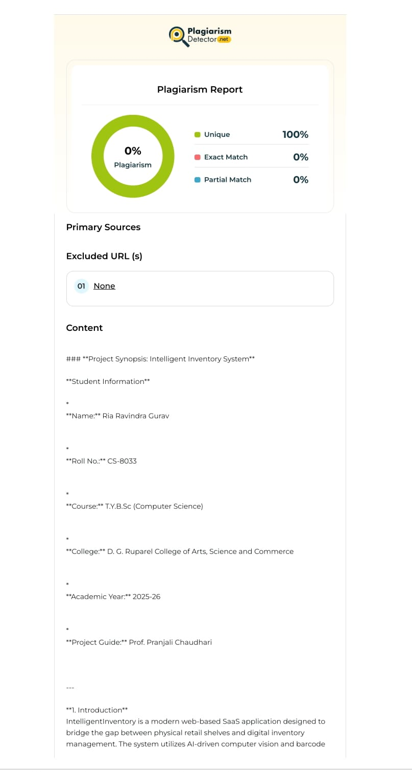

CHAPTER 1: INTRODUCTION
  - Background

The retail sector in India is experiencing rapid digital transformation driven by the adoption of cloud computing, automation, and smart technologies. Large retail chains have already embraced advanced inventory management systems, real-time analytics, and automated supply chains. However, a significant gap still exists in the small-to-medium enterprise (SME) segment, particularly among local Kirana stores and independent retailers. These businesses form the backbone of the Indian retail economy, yet most of them continue to rely on traditional, manual, and paper-based methods for managing inventory.
Manual inventory tracking poses several operational challenges. Stock entries are typically recorded by hand or maintained in basic spreadsheets, which are prone to human error, data duplication, and delayed updates. As a result, shop owners often do not have an accurate or real-time view of their available stock. This lack of inventory visibility leads to frequent situations where products run out unexpectedly, causing customer dissatisfaction and loss of sales. In competitive retail environments, even a single missed sale can impact customer loyalty and long-term business growth.
Another critical issue in traditional retail systems is ineffective expiry management. Perishable goods such as dairy products, packaged food items, and pharmaceutical medicines require strict monitoring of expiration dates. In the absence of automated alerts, expired products often remain unnoticed on shelves, leading to financial losses, regulatory risks, and potential health hazards for consumers. Store managers are forced to manually check expiry dates, a process that is time-consuming, inefficient, and unreliable when dealing with large inventories.
To address these challenges, the Intelligent Inventory Bot was designed as a cost-effective and smart solution tailored specifically for small retailers. The project aims to bridge the gap between physical inventory and digital management by leveraging modern technologies such as Computer Vision, Internet of Things (IoT), and cloud-based services. Instead of relying on expensive barcode scanners and proprietary hardware, the system uses a standard webcam to scan barcodes and product labels. This approach significantly reduces the cost of adoption and makes digital inventory systems accessible even to small shop owners with limited technical resources.
The system is built around a Software as a Service (SaaS) model, enabling scalability and multi-user support. Each retailer can securely manage their inventory data in an isolated cloud environment, ensuring data privacy and reliability. A Flask-based backend handles application logic and API services, while SQLAlchemy is used for efficient and structured database management. This architecture ensures seamless data storage, retrieval, and synchronization across devices.
In addition, the Intelligent Inventory Bot integrates an IoT-based notification mechanism using Telegram, allowing store owners to receive real-time alerts regarding low stock levels and upcoming product expiries. These proactive notifications enable timely restocking decisions and reduce operational waste. By providing remote access and instant updates, the system empowers retailers to manage their stores more efficiently without being physically present at all times.
Overall, the background of this project is rooted in the need for an affordable, scalable, and “Zero-Lag” smart inventory management system. The Intelligent Inventory Bot aims to enhance operational efficiency, minimize losses due to human error and expired products, and promote digital inclusion among small retail businesses. Through automation and intelligent monitoring, the project contributes to building a sustainable and technology-driven Smart Retail Ecosystem for the future.

1.2 Objectives
The primary objective of the Intelligent Inventory Bot is to modernize and optimize inventory and supply chain management for small-scale retail enterprises by replacing traditional, manual, and error-prone processes with an intelligent, automated, and digital workflow. The project focuses on delivering an affordable yet powerful solution that enables small retailers and local Kirana stores to access the same level of inventory intelligence typically available only to large corporate retail chains.
In the existing retail environment, limited access to technology, high costs of hardware, and lack of technical expertise prevent small business owners from adopting advanced inventory systems. This project aims to bridge that gap by offering a user-friendly, low-cost, and hardware-independent platform that improves accuracy, efficiency, and decision-making through automation and real-time monitoring.
The specific technical and functional objectives of the Intelligent Inventory Bot are outlined below:
- Automated Stock Identification
One of the key objectives is to eliminate manual data entry by implementing an automated product identification mechanism. The system uses Computer Vision techniques with OpenCV to scan and decode universal 1D barcodes using a standard webcam. This enables instant product recognition, reduces dependency on human input, minimizes transaction errors, and significantly improves billing and inventory update accuracy.
- Proactive Expiry Management
The project aims to develop an intelligent expiry monitoring engine that continuously tracks product expiration dates stored in the database. The system performs regular automated audits and generates alerts before items reach their expiry. By notifying the shop owner in advance, the system helps reduce losses due to expired goods, supports timely discounts or stock clearance, and ensures compliance with safety and quality standards.
- Real-Time IoT Alerts and Notifications
Another major objective is to integrate IoT-based communication through the Telegram Bot API. The system sends real-time notifications such as low-stock warnings and expiry reminders directly to the retailer’s mobile device. These alerts allow the business owner to take immediate action, such as restocking items, even when they are not physically present at the store.
- Multi-User SaaS Architecture
The project is designed as a Software as a Service (SaaS) platform that supports multiple users. Using the Flask web framework, the system allows multiple shopkeepers to register and manage their inventory independently. Each user’s data is securely stored and isolated, ensuring privacy, scalability, and efficient cloud-based operations.
- Audible AI Analytics and Voice Assistance
To improve accessibility and usability, especially during busy retail hours, the system includes a voice-enabled AI Assistant. This assistant can analyze real-time inventory data and provide spoken summaries such as stock availability, low-inventory items, and expiry status. This feature reduces the need for continuous screen interaction and enhances hands-free operation.
- Hardware Independence and Cost Efficiency
A crucial objective of the project is to ensure that the system remains affordable and accessible. The Intelligent Inventory Bot is designed to operate on commonly available hardware such as laptops, desktops, and mobile devices equipped with standard cameras. By avoiding expensive barcode scanners and proprietary equipment, the system ensures easy adoption across businesses of all sizes.
Overall, these objectives collectively ensure that the Intelligent Inventory Bot functions not merely as a digital inventory database, but as a proactive, intelligent business assistant. The system empowers small retailers with automation, real-time insights, and remote control, enabling them to reduce operational losses, improve customer satisfaction, and embrace digital transformation with minimal investment.

1.3 Purpose, Scope and Applicability

1.3.1 Purpose of this System
The primary purpose of the Intelligent Inventory Bot is to provide an accessible, high-tech inventory management platform that significantly reduces the manual workload of retail operators. By centralizing stock data and integrating it with real-time sensors and communication APIs, the system transforms a passive list of items into an active, "thinking" inventory. It aims to eliminate human oversight in monitoring critical business metrics, such as stock depletion and product expiration, ensuring that the business remains profitable and efficient.

1.3.2 Scope of this System
The functional scope of this project encompasses the entire lifecycle of retail data management:
- User Authentication: Secure onboarding of multiple business users through an encrypted registration and login portal.
- Inventory Management: A comprehensive CRUD (Create, Read, Update, Delete) interface for managing item names, barcodes, prices, and quantities.
- Real-time Computer Vision: Integration of the OpenCV library to detect and decode 1D barcodes via a standard laptop webcam.
- IoT Notification Engine: A background service that communicates with the Telegram Bot API to deliver instant push notifications to the user’s mobile device.
- Interactive AI Interface: A specialized module for audible data reporting, allowing users to interact with their inventory through a voice-enabled assistant.

1.3.3 Applicability
This system is designed for high versatility and can be deployed in various real-world scenarios:
- Retail Pharmacy: Where tracking the precise expiry dates of medications is legally and operationally vital.
- FMCG Outlets: For local grocery stores managing high-turnover products like milk, bread, and snacks.
- Boutique Warehousing: For small-scale distributors who need remote oversight of their stock levels without investing in heavy ERP software.
- Educational Labs: To manage and track the usage of lab equipment and consumables efficiently.

1.4 Achievement
The successful design and implementation of the Intelligent Inventory Bot marks a major achievement in developing an end-to-end smart retail solution by integrating multiple advanced technologies into a single, cohesive platform. The project demonstrates the practical feasibility of transforming traditional inventory management systems into an intelligent, automated, and proactive business tool suitable for small-scale enterprises.
One of the most notable achievements of the project is the successful hardware–software integration. By leveraging OpenCV-based Computer Vision, the system effectively converts a standard laptop webcam into a reliable and accurate barcode scanning device. This achievement validates the core objective of eliminating dependency on costly, specialized scanning hardware, thereby significantly reducing the overall deployment cost and making advanced inventory management accessible to small retailers.
Another key accomplishment is the implementation of real-time IoT communication using the Telegram Bot API. The project successfully establishes a direct communication channel between the server-side inventory database and the retailer’s mobile device. This integration enables instant delivery of critical alerts such as low-stock warnings and upcoming product expiries, achieving a near “zero-lag” notification system. As a result, store owners can respond to inventory issues promptly, even when operating remotely.
The project also achieves a major milestone through the development of a proactive inventory audit engine. Unlike conventional systems that only store and display data, the Intelligent Inventory Bot continuously analyzes stock levels and expiry dates without user intervention. The system automatically identifies low-quantity items and expired or near-expiry products and generates actionable alerts. This proactive logic transforms the system from a passive record-keeping tool into an intelligent decision-support system.
A further achievement lies in the successful integration of a user-centric AI interface. The voice-enabled AI Assistant allows users to receive spoken summaries of inventory status, including stock health and critical alerts. This feature enhances usability and accessibility, especially for non-technical shopkeepers and during peak business hours when hands-free interaction is beneficial. The inclusion of voice analytics demonstrates the project’s focus on real-world usability rather than purely technical implementation.
Finally, the project successfully implements a secure, scalable SaaS-based multi-tenant architecture. Using Flask, Flask-Login, and SQLAlchemy, the system ensures that multiple independent users can operate on the same platform while maintaining complete data isolation and privacy. Each retailer’s inventory data is securely managed without any risk of data leakage, validating the system’s readiness for real-world deployment and scalability.
In conclusion, the Intelligent Inventory Bot achieves its intended goals by combining automation, real-time communication, artificial intelligence, and secure cloud architecture into a unified solution. These achievements collectively demonstrate the system’s effectiveness as a modern, reliable, and intelligent inventory management platform capable of enhancing operational efficiency and supporting digital transformation in small retail businesses.

1.5 Gantt Chart
The development of this project followed a structured timeline to ensure all modules—from the initial requirement analysis to the final deployment—were thoroughly tested and integrated.

Phase | Activity | Duration | Start Date | End Date
Phase 1 | Requirement Analysis: Defining the problem of manual inventory tracking and specifying hardware/software needs. | 1 Week | Jan 1, 2026 | Feb 11, 2026
Phase 2 | System Design: Creating the database schema, Logic Diagrams, and User Interface wireframes. | 1 Week | Jan 8, 2026 | Feb 12, 2026
Phase 3 | Backend Implementation: Setting up the Flask server, SQLAlchemy database, and secure user authentication. | 2 Weeks | Jan 15, 2026 | Feb 13, 2026
Phase 4 | AI & IoT Integration: Developing the OpenCV barcode scanner and integrating the Telegram Bot API for alerts. | 2 Weeks | Jan 29, 2026 | Feb 14, 2026
Phase 5 | Testing & Documentation: Finalizing Unit/Integration tests and completing the TYCS project report. | 4 Days | Feb 12, 2026 | Feb 15, 2026

GANTT CHART
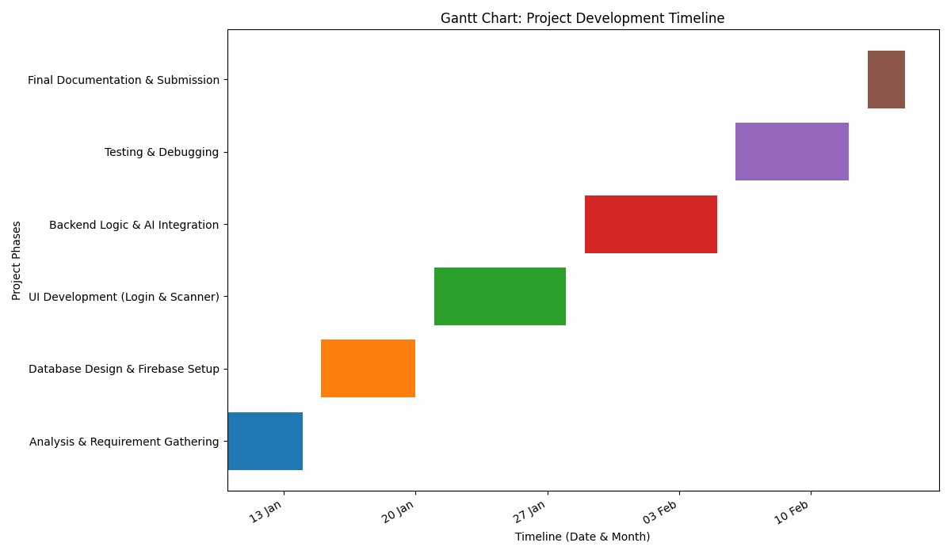

CHAPTER 2: REQUIREMENT AND ANALYSIS

2.1 Problem Definition
The foundation of the Intelligent Inventory Bot project lies in identifying and analyzing the persistent inefficiencies present in traditional inventory management systems used by small-scale retail businesses. Despite rapid technological advancements in the retail industry, a large number of local shops, Kirana stores, pharmacies, and small outlets continue to operate with minimal or no digital integration. These businesses largely depend on manual record-keeping methods, which result in a reactive operational model rather than a proactive and intelligent one.
One of the most critical problems identified during the requirement analysis phase is manual data entry and human error. Inventory details are commonly maintained using handwritten ledgers or basic spreadsheet files. This process is time-consuming and highly error-prone, as shopkeepers or staff may enter incorrect quantities, forget to update records after sales, or overlook damaged and returned items. Over time, these inconsistencies lead to what is commonly referred to as ghost inventory, where the recorded stock levels do not accurately reflect the physical stock available on the shelves. Such discrepancies negatively impact purchasing decisions and inventory planning.
Another major issue is inventory invisibility and frequent stock-outs. In the absence of a real-time inventory tracking system, business owners have limited visibility into their stock levels, especially when they are not physically present at the store. As a result, products often run out unexpectedly, particularly fast-moving or high-demand items. Stock-outs not only lead to immediate loss of sales but also reduce customer trust and satisfaction, as customers may choose alternative stores for future purchases.
Inefficient expiry management is another serious concern, especially for businesses dealing with perishable goods, packaged food items, or pharmaceutical products. In manual systems, monitoring expiration dates requires regular physical inspection of products, which is both labor-intensive and unreliable. Due to oversight or workload pressure, expired products often remain unnoticed on shelves, leading to financial loss, regulatory non-compliance, and potential health risks to consumers. For pharmacies and food retailers, this issue can result in serious legal and ethical consequences.
The high cost of existing automation solutions further aggravates the problem. Most enterprise-level inventory management systems require expensive dedicated hardware such as industrial barcode scanners, RFID readers, and on-premise server infrastructure. These solutions are designed for large retail chains and are economically unviable for small business owners. The high initial investment, coupled with maintenance and training costs, creates a significant barrier to digital adoption for local retailers.
Additionally, there is a lack of instant communication and alert mechanisms in traditional systems. Even when inventory records are maintained manually or digitally, there is no automated or real-time notification system to inform the shopkeeper about critical situations such as low stock levels or approaching expiry dates. Consequently, urgent issues are often discovered hours or days later, by which time corrective action becomes difficult or ineffective. This delay directly impacts operational efficiency and revenue generation.
In summary, traditional inventory management systems used by small-scale retailers suffer from inaccuracies, inefficiencies, delayed decision-making, and high operational risk. These challenges highlight the need for an affordable, automated, and intelligent solution. By clearly defining these problems, the Intelligent Inventory Bot aims to leverage Computer Vision and IoT-based communication to eliminate manual dependency, improve real-time visibility, reduce losses, and enable a proactive inventory management approach tailored specifically for small retail enterprises.

2.2 Requirement Specification
The requirement specification phase converts the problems identified in the previous section into clear, measurable, and implementable system requirements. These requirements define the expected behavior, performance, and constraints of the Intelligent Inventory Bot. The goal of this phase is to ensure that the final system meets both business needs and technical feasibility while remaining scalable, secure, and user-friendly.
The requirements are broadly classified into functional requirements, which describe what the system should do, and non-functional requirements, which define how well the system should perform under real-world conditions.

2.2.1 Functional Requirements
User Account Management
The system must provide a secure user registration and authentication mechanism. Each shopkeeper should be able to create a unique account and log in using valid credentials. User authentication ensures that inventory data is private and isolated for each business owner, preventing unauthorized access or data overlap in a multi-user SaaS environment.
Real-Time Barcode Detection
The application must interface with a standard laptop or mobile webcam to capture live video frames and detect 1D barcodes such as EAN-13 and UPC codes. Using OpenCV-based Computer Vision, the system should decode barcodes in real time, allowing instant product identification without manual data entry or the need for dedicated scanning hardware.
Inventory Database Operations
The system must support complete inventory management through CRUD (Create, Read, Update, Delete) operations. Users should be able to add new products, update stock quantities, modify product details, and remove obsolete items. All changes must be immediately reflected in the backend database managed using SQLAlchemy, ensuring data consistency and persistence.
Automated Expiry Auditing
The backend system must include an automated auditing mechanism that continuously compares the current system date with stored product expiry dates. Items that are expired or nearing expiry should be flagged automatically, enabling timely action such as stock clearance or removal from sale.
IoT Notification Dispatch
The system must autonomously trigger notifications when predefined conditions are met, such as low stock levels or approaching expiry dates. Using HTTP-based communication with the Telegram Bot API, alerts must be delivered instantly to the shopkeeper’s mobile device, ensuring real-time awareness and quick decision-making.
Voice Assistant Interface
The system must include a voice-enabled interface that supports either Text-to-Speech or Speech-to-Text functionality. This feature allows users to receive audible summaries of inventory status, including stock health and critical alerts, enabling hands-free interaction during busy store operations.

2.2.2 Non-Functional Requirements
Data Integrity
The system must ensure accurate and consistent inventory data at all times. Stock quantities must be updated correctly after every barcode scan, sale, or manual edit, with no data duplication or loss. Database transactions should maintain reliability even during concurrent operations.
Security
User authentication and session management must be implemented securely. Passwords should be stored in encrypted or hashed form, and access to inventory data should be restricted to authorized users only. This ensures protection against unauthorized access and data breaches.
Responsiveness
The web-based dashboard must be responsive and adaptable to different screen sizes. Business owners should be able to monitor and manage inventory using laptops, tablets, or mobile phones without loss of functionality or usability.
Availability
The system should remain operational during business hours with minimal downtime. Inventory updates, barcode scanning, and alert notifications must function reliably to ensure uninterrupted business operations.
User-Friendly Interface
The user interface must be simple, intuitive, and easy to navigate for non-technical users. Features such as clearly labeled buttons, high-contrast text, dark mode for low-light environments, and minimal screen clutter should be incorporated to enhance usability and reduce learning time.
In conclusion, the requirement specification ensures that the Intelligent Inventory Bot is not only functionally robust but also reliable, secure, and user-centric. These requirements serve as a blueprint for system design and implementation, ensuring that the final product effectively addresses the real-world challenges faced by small-scale retailers.

2.3 Planning and Scheduling
The planning and scheduling phase played a crucial role in ensuring that the Intelligent Inventory Bot was successfully developed within the constraints of the academic semester. A well-defined project plan was necessary to manage time effectively, reduce development risks, and ensure smooth integration of multiple technologies such as Computer Vision, IoT, and web-based SaaS architecture.
An Agile-inspired development methodology was adopted for this project. Instead of following a rigid, linear model, the project was divided into clearly defined development sprints. This approach enabled iterative development, continuous testing, and early identification of technical challenges, particularly during the integration of OpenCV-based barcode scanning and Telegram-based IoT notifications.
As illustrated in the Gantt Chart, the project timeline was strictly managed over a period of six weeks, from January 1st to February 15th, 2026. Each phase was assigned specific deliverables to ensure steady progress and timely completion.
During Week 1 (Research and Feasibility Analysis), the focus was on understanding the problem domain in depth and validating the technical feasibility of the proposed solution. Extensive research was conducted on existing inventory management systems, barcode standards, and the compatibility of OpenCV with the Flask framework for real-time image processing.
Week 2 (System Design) was dedicated to architectural planning and system modeling. Various UML diagrams, including Use Case, Class, and Sequence diagrams, were prepared to clearly define system behavior and interactions. In parallel, the SQLAlchemy database schema was designed with special emphasis on supporting multi-user data isolation and secure SaaS deployment.
The core development phase occurred during Week 3 and Week 4 (Backend Development). This stage involved implementing the Flask-based server logic, user authentication and session management using Flask-Login, and the complete inventory CRUD (Create, Read, Update, Delete) functionality. Continuous unit testing was performed to validate system stability and data integrity.
In Week 5 (AI and IoT Integration), advanced components were integrated into the system. This included configuring the OpenCV BarcodeDetector for real-time product identification and integrating the Telegram Bot API to enable instant IoT-based alerts for low-stock and expiry conditions. This phase required extensive testing to ensure reliable communication between the backend server and user devices.
Finally, Week 6 (Testing and Documentation) focused on comprehensive system validation and project documentation. Both unit testing and integration testing were carried out to ensure that all modules functioned cohesively. The phase concluded with the preparation of a blackbook , documenting system design, implementation, testing, and results.

2.4 Software and Hardware Specification
To ensure that the Intelligent Inventory Bot remains affordable and accessible to small-scale retailers, careful consideration was given to selecting lightweight, efficient software tools and minimal hardware requirements. The system is designed to run on commonly available consumer-grade hardware without the need for specialized equipment.

Hardware Requirements
Component | Minimum Specification | Purpose
Processor | Dual-core 2.4GHz or higher | To handle real-time image processing
RAM | 8 GB | To run the Flask server and OpenCV concurrently
Camera | Integrated or External 720p HD Webcam | To capture clear barcode images for decoding
Storage | 500 MB available space | For the SQLite database and application files
Internet | Stable Broadband/4G | For dispatching IoT alerts via Telegram

Software Requirements

Tool / Library | Version / Type | Role in Project
Operating System | Windows 10/11 or Ubuntu Linux | Host Environment
Programming Language | Python 3.10+ | Core logic and backend development
Web Framework | Flask 2.x | Routing, SaaS architecture, and UI rendering
Database | SQLite | Lightweight storage for user and product data
ORM | SQLAlchemy | To interact with the database using Python objects
Computer Vision | OpenCV-Python | Image processing and barcode detection
IoT Integration | Telegram Bot API | Delivering remote mobile notifications

CHAPTER 3: SYSTEM DESIGN

3.1 Basic Modules
To ensure a robust and maintainable architecture for the Intelligent Inventory Bot, the system is designed using a modular approach. Each module is responsible for a specific functional domain, allowing for efficient debugging and future scalability.
The five core modules of the system are as follows:
- User Authentication Module:
  - This module manages the security layer of the application using Flask-Login.
  - It handles user registration, password hashing, and session management to ensure that each shopkeeper's data remains private and isolated from others.
- Inventory Management Module (CRUD):
  - Acting as the primary administrative interface, this module allows users to perform Create, Read, Update, and Delete operations on their stock.
  - It communicates directly with the SQLAlchemy ORM to store and retrieve product details like names, prices, and quantities.
- AI Vision Module:
  - This module integrates the OpenCV library to transform a standard webcam into a high-speed barcode scanner.
  - It utilizes the BarcodeDetector class to recognize and decode 1D barcodes in real-time, which then triggers automated stock deductions in the database.
- IoT Notification Engine:
  - This is the proactive communication layer of the project, built using the Telegram Bot API.
  - It continuously monitors the inventory for two conditions: stock levels falling below a set threshold (e.g., 5 units) and products reaching their expiration date, immediately dispatching alerts to the user's mobile device.
- Voice Analytics Module:
  - To improve accessibility, this module provides a voice-enabled interface that can read out inventory summaries.
  - It allows shopkeepers to receive "hands-free" status updates about their business during busy operational hours.

3.2 Data Design
Data design is a critical phase that ensures the Intelligent Inventory Bot can store, retrieve, and manage business information accurately while maintaining high performance. It involves defining the structural relationship between different data entities and the rules that govern them.

3.2.1 Schema Design
The database utilizes a relational model implemented through SQLite and managed via the SQLAlchemy ORM. The architecture follows a one-to-many relationship, where a single registered user can own and manage multiple unique products.
- User Table: This table stores the credentials for the shopkeepers.
  - id: Primary Key (Integer) to uniquely identify each business account.
  - username: Unique string used for login identification.
  - password: Hashed string for secure authentication.

- Product Table: This table contains the inventory details.
  - id: Primary Key (Integer).
  - name: The display name of the product (e.g., "Oreo Biscuits").
  - barcode: A unique string representing the 1D barcode of the item.
  - quantity: Integer representing current stock levels.
  - price: Float representing the unit cost.
  - expiry_date: String or Date field used for the proactive audit engine.
  - user_id: Foreign Key linking the product to its specific owner in the User table.

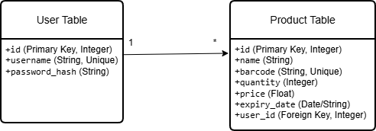

3.2.2 Data Integrity and Constraints
To ensure that the Intelligent Inventory Bot maintains a single source of truth and prevents database inconsistencies, multiple data integrity constraints are enforced within the SQLAlchemy ORM models. These constraints are critical for the system’s intelligent behavior, as inaccurate or inconsistent data could result in incorrect inventory calculations and false IoT notifications.

1. Entity Integrity (Primary Keys)
Each record in the User and Product tables is uniquely identified using an auto-incremented Integer Primary Key (id).
- This guarantees that every user and product has a unique internal identifier.
- It prevents ambiguity even when multiple products or users have similar names.

2. Referential Integrity (Foreign Keys)
The Product table includes a Foreign Key (user_id) that references the id field of the User table.
- Relationship Type: A One-to-Many relationship is enforced, where one user can own multiple products.
- Ownership Validation: Every inventory item is associated with a valid, authenticated shopkeeper.
- Cascading Rules: If a user account is deleted, all related product records are automatically removed, preventing orphaned records and ensuring database consistency.

3. Domain Integrity (Data Types and Field Constraints)
Domain-level constraints ensure that all stored data falls within valid and expected ranges.
- Uniqueness Constraint:
The barcode field is defined with unique=True, preventing duplicate barcode assignments across products.
- Nullability Constraint:
Essential fields such as username, barcode, and product_name are defined with nullable=False, ensuring that critical information is always present.
- Default Values:
The quantity field is assigned a default value of 0, providing a reliable baseline for inventory tracking and alert logic.

4. Business Logic Constraints
Certain rules are enforced at the application level to maintain logical consistency.
- Positive Inventory Constraint:
Validation logic ensures that product quantity never falls below zero during barcode scanning operations.
- IoT Alert Threshold:
A predefined constraint (quantity < 5) triggers the Telegram notification system, enabling proactive low-stock alerts for shopkeepers.

3.3 Logic Diagrams
Logic diagrams visually represent how the Intelligent Inventory Bot processes data and interacts with users. They illustrate the flow of operations such as user authentication, barcode scanning, inventory updates, expiry checks, and alert generation. These diagrams help in understanding system decision-making, data flow between modules, and interactions with external services like the Telegram Bot API. Overall, logic diagrams provide a clear and simplified view of the system’s internal working and support effective system design and implementation.

3.3.1 Event Table
The Event Table is a fundamental design tool used to define the dynamic behavior of the Intelligent Inventory Bot. It maps specific external or internal triggers to the corresponding system responses, ensuring that every user interaction results in a predictable and accurate outcome.
Event Trigger | Event Condition | System Action / Processing | Output / Result
New User Registration | User submits unique username and password. | The system hashes the password and creates a new record in the User Table. | Account created; User redirected to Login page.
User Login | Credentials match the stored hash in the database. | Flask-Login establishes a secure user session. | Access granted to the private Business Dashboard.
Product Addition | User enters name, barcode, and quantity. | Validates data and saves a new entry in the Product Table linked to the user ID. | Inventory updated; Product appears in the list.
Barcode Scan | Webcam detects a valid 1D barcode frame. | OpenCV decodes the image and performs a database lookup for the barcode string. | Quantity is automatically decremented by 1.
Inventory Depletion | Updated quantity becomes less than 5 units. | The backend triggers an HTTP request to the Telegram Bot API. | ⚠️ Low Stock Alert sent to the user's mobile device.
Expiry Audit | System date ≥ Product expiry date. | The audit engine flags the item during the dashboard load. | 🚨 Expiry Notification displayed and sent via IoT.
Voice Status Request | User clicks the "Voice Assistant" button. | The system processes inventory counts and generates a text summary. | Audible summary played through the device speakers.

3.3.2 Use Case Diagram
Unified Modeling Language (UML) is a graphical representation that illustrates the interactions between actors (users or external systems) and a system, showcasing various use cases or functionalities that the system provides. It helps in understanding the functional requirements of a system from the perspective of its users. Key Components of a Use Case Diagram:
● Actors: Represent external entities interacting with the system. Actors could be users, other systems, or entities external to the system being modelled. Displayed as stick figures or labeled ovals.
● Use Cases: Represent functionalities or services offered by the system to its actors. Described as ovals containing the name of the use case. Each use case describes a specific interaction or task that the system performs for an actor.
● Relationships: Associations (lines) between actors and use cases, showing the interaction between them. Actors are associated with use cases that they interact with or perform.
● System Boundary: Represents the scope or boundary of the system under consideration. Encloses all the use cases and actors involved in the system.
Purpose of Use Case Diagrams:
● Requirement Analysis: Use case diagrams help in eliciting, organizing, and understanding the functional requirements of a system from the perspective of its users or external entities.
● Communication: They serve as a communication tool among stakeholders, aiding in understanding the system's functionalities and interactions.
● System Design: Use case diagrams provide a foundation for system design by outlining the system's functionality and actors involved. Use case diagrams provide a high-level view of the system's functionalities and interactions, aiding in requirement analysis, system understanding, and communication among stakeholders during the early stages of system development.
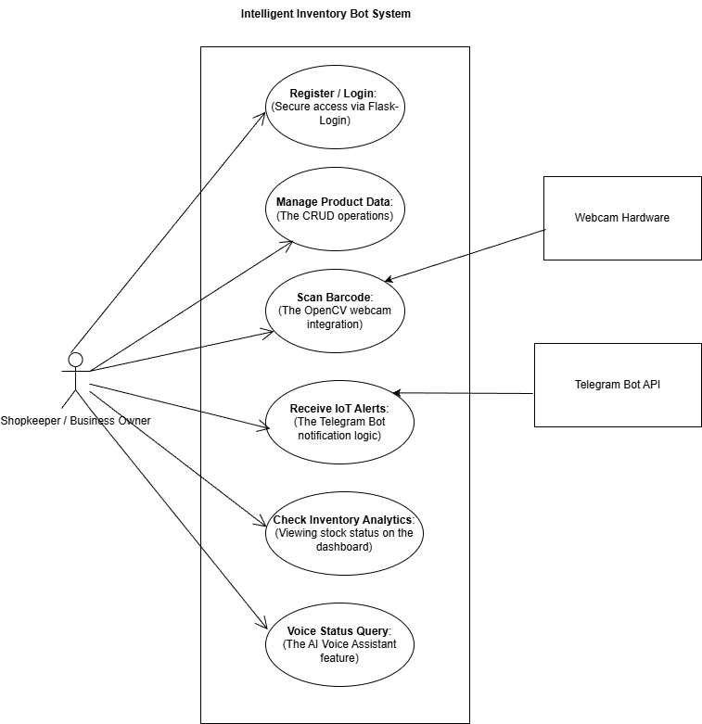

3.3.3 Activity Diagram:

An activity diagram in the Unified Modeling Language (UML) is a behavioural diagram that illustrates the flow of activities or actions within a system or a process. It displays the sequence of actions, decisions, and transitions that take place to accomplish a particular task or a series of tasks. Activity diagrams are particularly useful in modeling workflows, business processes, and system behaviours.
Key Components of a Use Case Diagram:

● Initial and Final Nodes: Initial node: Represents the starting point of the activity diagram. Final node: Indicates the end or completion point of the activity flow.

● Activities: Actions or tasks to be performed in the system/process. Represented as rounded rectangles labeled with action names. Activities can be simple actions or complex sub-activities.

● Control and Object Flow: Control flow arrows: Show the sequence of activities and the order in which actions are executed. Object flow arrows: Illustrate the flow of objects or data between activities.

● Decisions (Decisions and Branches): Diamond-shaped nodes representing decision points. Based on conditions or outcomes, the flow of activities diverges

● Forks and Joins: Fork nodes: Split the flow of activities into multiple concurrent paths. Join nodes: Merge the concurrent paths back into a single flow.

● Swimlanes (Partitions): Horizontal or vertical lanes used to group activities based on responsible entities or systems.

Purpose of Activity Diagrams:
● Modeling Workflows and Business Processes: Activity diagrams help in modeling and understanding workflows and business processes within a system or organization.
● Visualizing System Behavior: They provide a visual representation of the sequence of actions and decisions in a system, aiding understanding system behaviour and logic.

Activity diagrams provide a clear visualization of the flow of actions, decisions, and control structures in a system or process, aiding in the analysis, understanding, and communication of complex workflows and business processes.

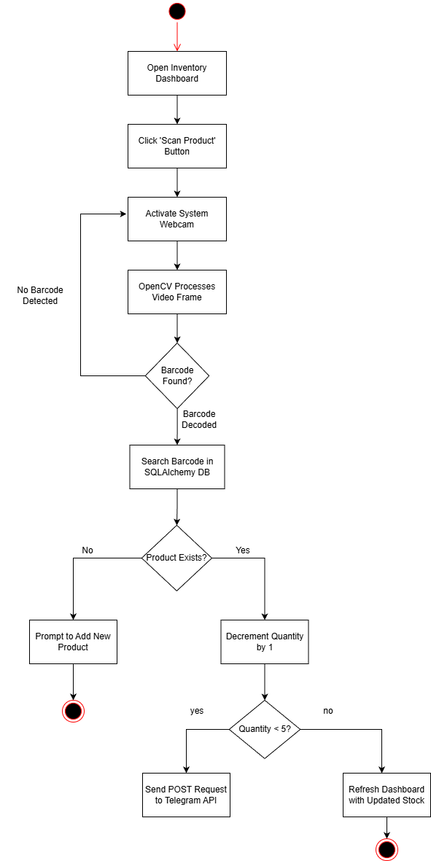
3.3.4 Class Diagram
A class diagram is a type of UML (Unified Modeling Language) diagram that illustrates the structure and relationships of classes, their attributes, methods, and associations within an object-oriented system. It provides a graphical representation of the system's static structure, showcasing the various entities (classes) and how they relate to each other.
Component of a Class Diagram:
1. Class:
● A class is a blueprint for objects. It defines a type of object by specifying the attributes and behaviors (methods) that the objects of this class will have.
● In a class diagram, a class is depicted as a rectangle, with three compartments:

- Class Name: The name of the class.
- Attributes: The properties or characteristics of the class.
- Methods (Operations): The behaviors or functions that the class can perform.

2. Attributes:
● Attributes are the data or properties that define a class. These typically hold the state of an object created from the class.
● Attributes are written with their name and type

3. Methods (Operations):
● Methods represent the behavior of the class or what the class can do. These are functions that can be executed by instances (objects) of the class.

4. Relationships:
The relationships between classes define how the classes interact with each other. The main types of relationships in a class diagram are:
● Association: A basic relationship between two classes. It represents that one class can communicate or interact with another class.
● Aggregation: A type of association where one class is a part of another class but can exist independently. It's a "has-a" relationship.
● Composition: A stronger form of aggregation where one class is a part of another and cannot exist independently (e.g., a car and its engine).
● Inheritance (Generalization): This represents an "is-a" relationship where a subclass inherits attributes and methods from a superclass.
● Dependency: A weaker relationship that shows that one class depends on another for some behavior or functionality.

5. Interface:
An interface defines a contract specifying a set of methods that a class implementing the interface must implement. Represented similar to a class but with the stereotype "<interface>" above the class name.

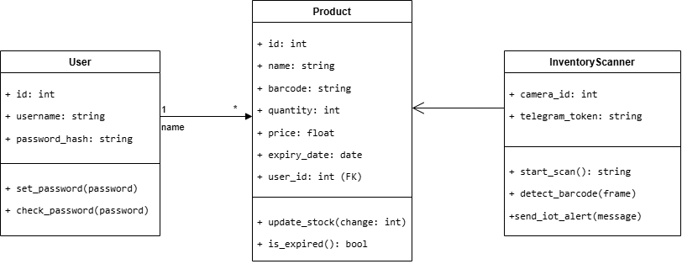

3.3.5. Object Diagram

An object diagram, also known as an instance diagram, is a type of UML (Unified ModelingLanguage)diagram that represents a snapshot of objects and their relationships at a specific point in time within a system. Unlike class diagrams that illustrate the structure and static relationships between classes, object diagrams focus on instances of classes and their associations at runtime.
Key Features of an Object Diagram:

1.Instances of Classes: An object diagram portrays instances (objects) of classes, showing how these objects interact and relate each other in a particular scenario.

2.Object Representation: Each object is represented as a box or oval labeled with the object's name and values for its attributes.

3.Associations and Relationships: Object diagrams display the associations and relationships between objects using lines connecting the objects, indicating how they are related or linked.

4.Snapshot in Time: Object diagrams capture a specific moment or state in the execution of a system, depicting the current relationships between objects at that instant.

5.Clarity on Object Structure: They provide clarity on the structure and associations between objects during system execution, aiding understanding object interactions and dependencies.

6.Purpose of Object Diagrams: Visualization of Object Structures: Object diagrams offer a visual representation of how instances of classes interact, showcasing relationships and collaborations between objects in the system.

7.Debugging and Analysis: They help in debugging and analyzing system behavior by illustrating object relationships at a particular point in time, aiding in identifying issues related to object interactions.

8.Communication and Design: Object diagrams facilitate communication among stakeholders by presenting a tangible view of object instances and their relationships, assisting in the design and communication of system structures.

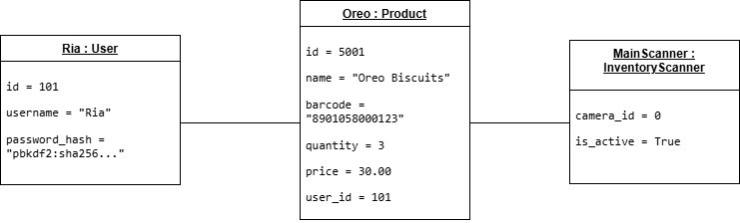

3.3.6 Sequence Diagram

A sequence diagram is a type of UML (Unified Modeling Language) diagram that illustrates the interactions between objects or components within a system in a time-ordered sequence. It displays the sequence of messages exchanged between objects over time to accomplish a particular functionality or scenario.

Key Components of a Sequence Diagram:

1. Objects (Participants): Represented as vertical lifelines (usually a dashed line) where objects or entities reside during the sequence of interactions.

2. Messages: Represented as arrows between lifelines, indicating the flow of communication or messages passed between objects.
Messages can be synchronous (denoted by a solid arrow), asynchronous (denoted by a dashed arrow), orself-messages (looping back to the same lifeline).

3. Activation Boxes (Execution Occurrences): Boxes along the lifeline representing the duration of time an object is performing an operation or processing message.
Depicts the time span during which an object is actively engaged in processing

4. Return Messages: Represented as arrows in the opposite direction of the initial message, denoting the response or return from the recipient object to the sender.

5. Optional Elements: Other optional elements include conditional statements, loops, parallel execution, and alternative scenarios depicted using combined fragments (e.g., loops, alternatives) and annotations (e.g., conditions).

Purpose of Sequence Diagrams:

1. Visualization of Interactions: Sequence diagrams visually represent the flow and order of interactions between various objects or components, aiding in understanding the dynamic behavior of a system.

2. Understanding System Behavior: They help in understanding how objects collaborate and communicate with each other to accomplish specific functionalities or use cases.

3. Design and Analysis: Sequence diagrams assist in designing and analyzing the system by showcasing the sequence of messages exchanged between objects during a specific scenario or process.
Sequence diagrams provide a visual representation of the sequence of interactions between objects, helping in understanding system behavior and communication patterns during specific scenarios or processes within a system.

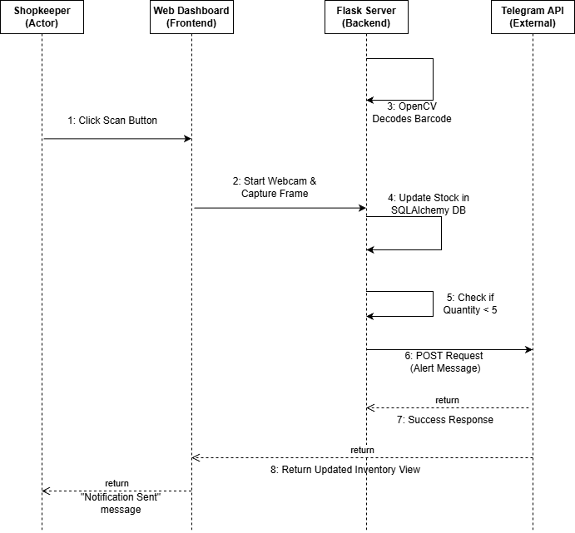

3.3.7 State chart Diagram

A state chart diagram, also known as a state machine diagram, is a type of UML(UnifiedModelingLanguage) diagram used to model the dynamic behavior of a system or an entity in response to various events over time. It illustrates the different states that an object or system can be in and how it transitions between those states in response to external stimuli or events.

Key Components of a State Chart Diagram:

1. States:
Represent the different conditions or situations in which an object or system exists. Depicted as rounded rectangles with the state name written inside.

2. Transitions:
Arrows between states indicating the flow or change from one state to another. Triggered by events or conditions that cause the system to transition from one state to another.
Labeled with the event triggering the transition.

3. Initial and Final States:
Initial state denoting the starting point of the system before any event occurs. Final state indicating the completion or termination of the system's process.

4. Actions and Activities:
Actions or activities associated with states or transitions, representing the operations performed when transitioning between states.

5. Events:
External stimuli or occurrences that cause a transition between states. Events can be user actions, system inputs, time-based triggers, etc.

Purpose of State Chart Diagrams:

1. Modeling System Behavior:
State chart diagrams model the behavior of a system or an entity by depicting how it responds to various events by transitioning between different states.

2. Understanding State Transitions:
They aid in understanding the sequence and conditions under which a system transitions from one state to another, along with the associated actions or activities.

3. Design and Analysis:
State chart diagrams assist in the design and analysis of systems, especially systems with complex behavior or numerous states, by visualizing the system's behavior in response to different events.
State chart diagrams effectively illustrate the behavioural aspects of systems by modeling their states,transitions, and associated events or actions, making it easier to understand and analyze the dynamic behavior of a system
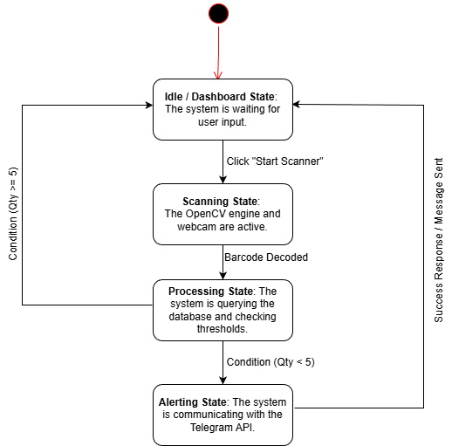

3.3.8 Component Diagram

A component diagram in the Unified Modeling Language (UML) is a type of structural diagram that visualizes the components of a system and their relationships. It focuses on the physical components or modules in a system, showcasing how they interact to achieve the system's functionalities.

Key Components of a Component Diagram:

1. Components:
Represent individual parts or building blocks of a system, often implemented or replaceable parts with well-defined interfaces.
Shown as rectangles with the component name written inside.

2. Interfaces: Represented by a small circle on the edge of a component. Interfaces define the communication points or contracts provided by the component to interact with other components or systems.

3. Dependencies: Arrows indicating the relationships and dependencies between components. Dependencies can be directed (indicating a unidirectional relationship) or bidirectional (indicating mutual reliance).

4. Connectors: Represent the communication paths or associations between components. Connectors might be lines, arrows, or dashed lines, depending on the nature of the relationship between components.

5. Ports: Entry or exit points of a component, often linked to interfaces. Represented by small squares on the edge of a component.
Purpose of Component Diagrams:

1. System Architecture Visualization: Component diagrams provide a high-level view of the system's architecture, depicting the physical components and their relationships within the system.

2. Component Identification: They help in identifying the individual components/modules of a system and their interconnections, facilitating system understanding.

3. Design and Development: Component diagrams aid in system design and development by defining the structure and relationships between components, guiding developers in implementing and integrating system components
Component diagrams visually represent the physical components and their relationships within a system, helping in system design, architecture visualization, and understanding the system's structure and interconnections.

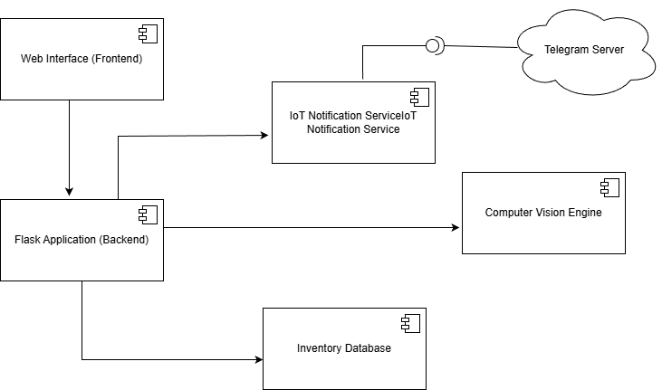

3.3.9 Deployment Diagram

A deployment diagram in the Unified Modeling Language (UML) is a type of diagram that illustrates the physical hardware components (nodes) and the software components (artifacts) of a system,showcasing their interconnections and deployment configurations. This diagram provides a visual representation of how software components are deployed on hardware nodes in a system's environment.
Key Components of a Deployment Diagram:

1. Nodes:
Represent physical hardware devices or computing resources where software components are deployed.Nodes can include servers, PCs, mobile devices, routers, or any hardware device relevant to the system's architecture. Displayed as boxes with the node's name written inside.

2. Artifacts:
Represent software components or modules that are deployed on the nodes. Examples include executable files, libraries, databases, configuration files, etc. Shown as rectangles with the artifact's name written inside.

3. Deployment Relationships:
Lines with arrows indicating the deployment relationships between nodes and artifacts. Show how artifacts are allocated or deployed on specific nodes. May include associations, dependencies, or connections between nodes and artifacts.

4. Association Links:
Represent communication paths or connectivity between nodes. Displayed as lines connecting nodes, denoting the communication channels or network connectionsbetween hardware devices.

Purpose of Deployment Diagrams:

1. System Deployment Visualization: Deployment diagrams provide an overview of how software components are distributed and deployed across physical hardware nodes in a system's environment.

2. Hardware and Software Configuration:
They show the mapping of software components to hardware nodes, aiding in understanding the system's configuration and deployment structure.

3. System Maintenance and Upgrades:
Deployment diagrams assist in planning system maintenance, upgrades, or scaling by visualizing the relationships between hardware and software components.
Deployment diagrams effectively showcase the physical deployment of software components onto hardware nodes, providing insights into the system's configuration, allocation of resources, and interactions between different components within the deployment environment.
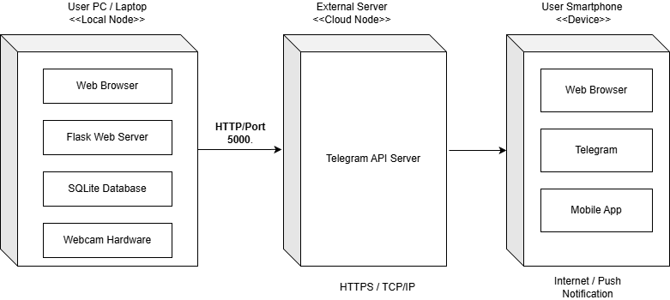

3.4. User Interface

1. Entry & Security (Welcome, Login, and Register)
The entry system provides a secure gateway for users, featuring a high-speed authentication module built with Flask-Login to ensure role-based access to private inventory data.

- WELCOME PAGE
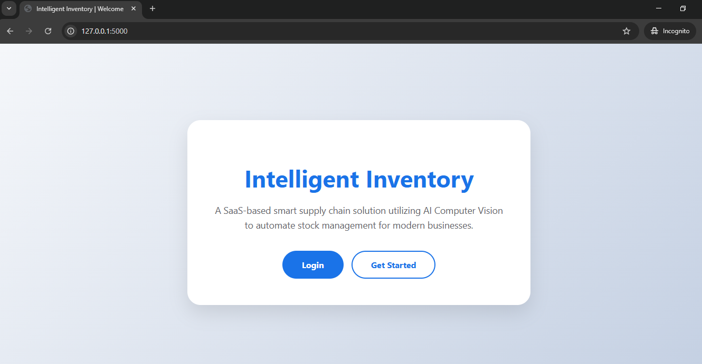

- LOGIN PAGE
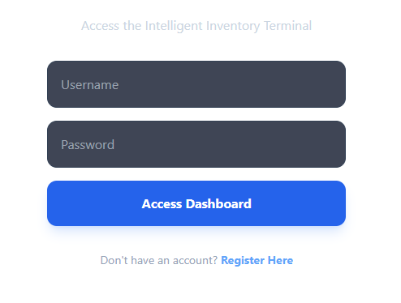
- REGISTER PAGE
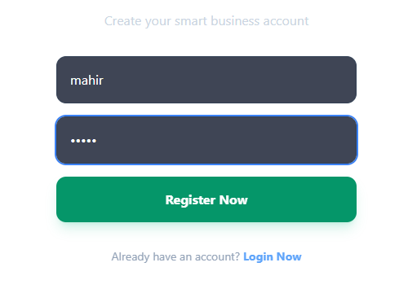
The User Interface of the Intelligent Inventory System is designed using a Glassmorphism-inspired theme built on the Tailwind CSS framework. The interface is optimized for high-speed retail environments where visual clarity is essential.
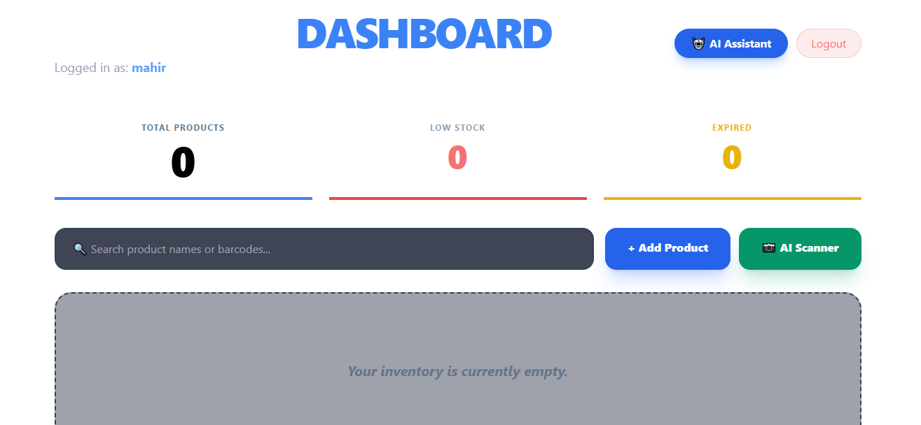
Key UI Components
- Dynamic Dashboard Header: Features a massive bold heading using the 'Plus Jakarta Sans' font to establish a strong visual brand identity.
- Real-Time Analytics Tiles: Three centralized cards provide an immediate audit of inventory health, using a color-coded border system for rapid data recognition.
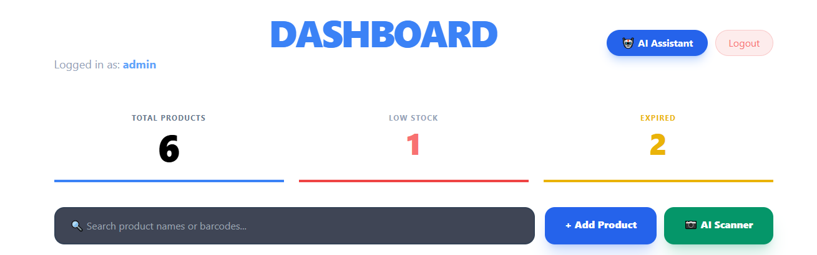
- Visual Audit Grid: The product list utilizes a reactive border system where the application logic automatically highlights items in Red if quantity is below 5 units, or Blue for healthy stock levels.
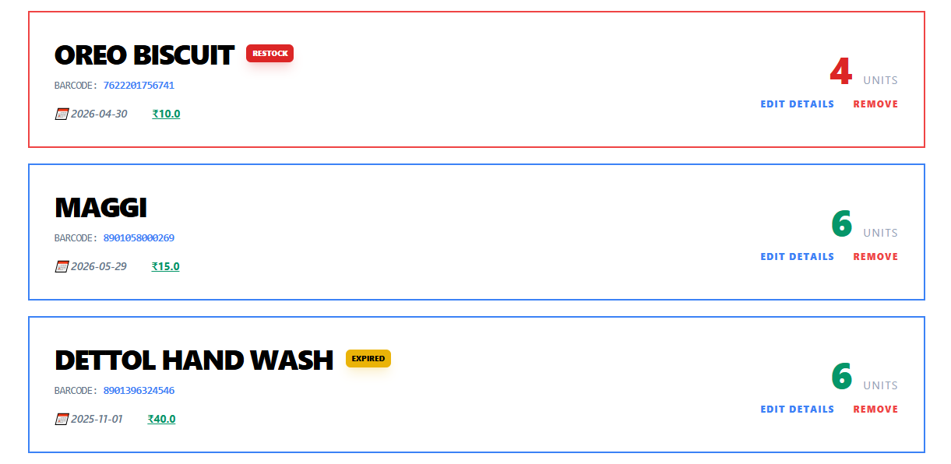
- AI Assistant Overlay: Integrating OpenCV and Google ML Kit, the AI Scanner module enables instant product identification, which is followed by a verbal and visual inventory health report generated by the AI Assistant.
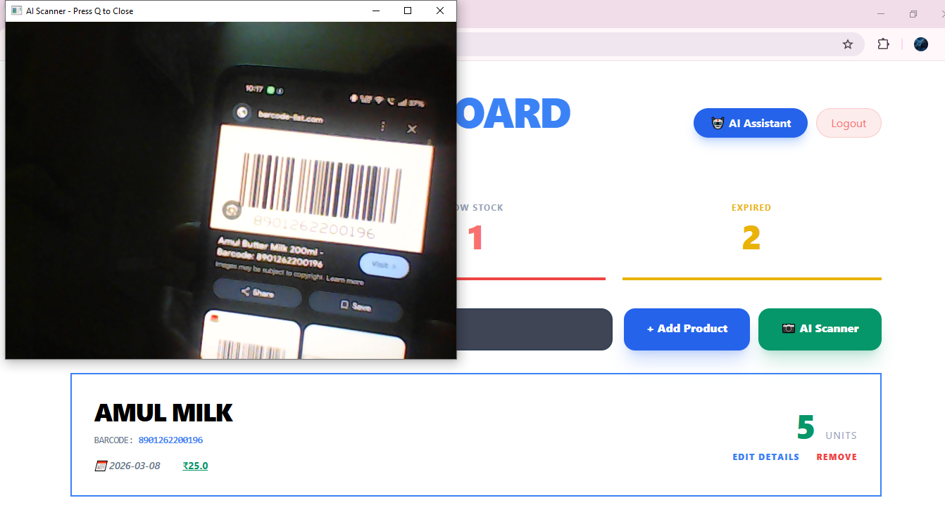
Beyond the dashboard, the system utilizes a multi-channel alert logic where the AI Assistant provides on-screen health reports, while the Telegram Bot API sends real-time restock and expiry notifications directly to the manager's mobile device.

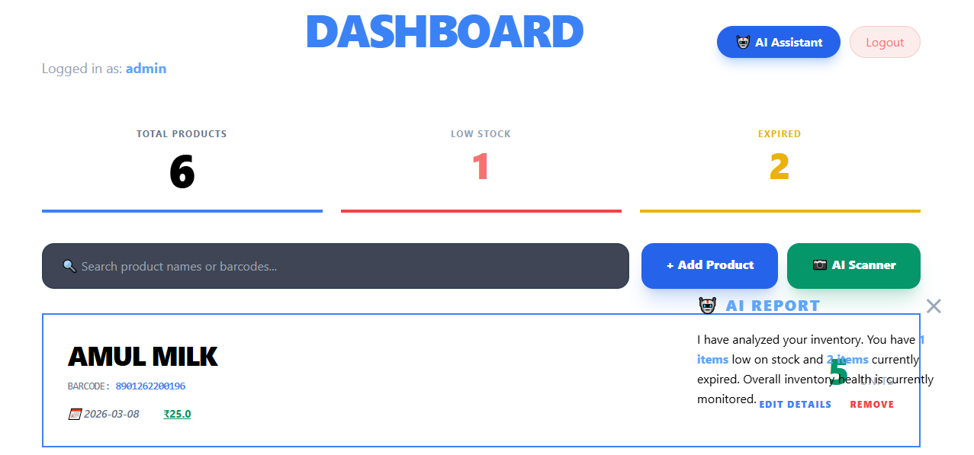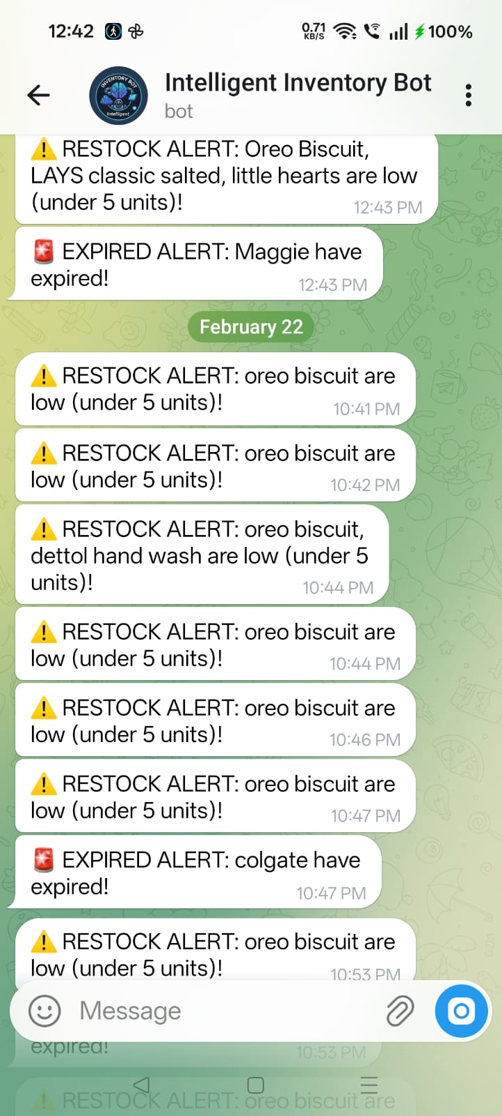

Data Management (Add & Edit Product)
The administration module provides intuitive forms for the digital registration of physical goods, allowing for the precise tracking of barcode IDs, pricing, and perishable lifecycles.
- ADD PRODUCT
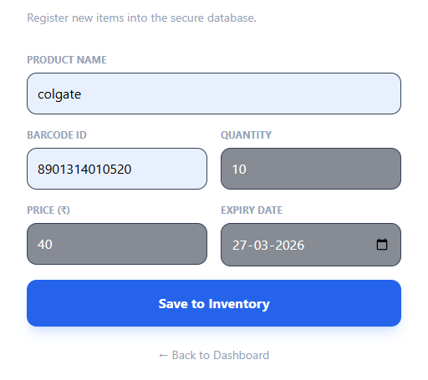
- EDIT PRODUCT
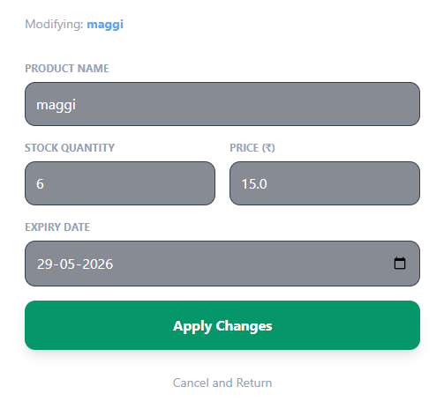
- Responsive Search Interface: A prominent, dark-themed search bar allows staff to filter the inventory by product name or barcode instantly as they type.
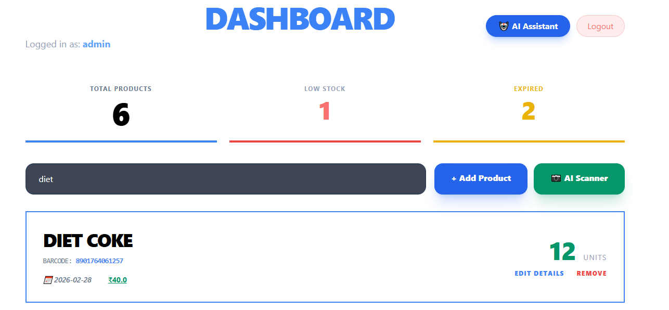
Design Philosophy: The UI focuses on minimalism and boldness. By using a dark radial gradient background and high-opacity white cards, the system ensures that critical warnings, such as "RESTOCK" and "EXPIRED" labels, are the most prominent elements on the screen.

3.5 Test Case Design
The testing phase is critical to ensure that the Intelligent Inventory Bot meets all functional requirements and handles errors gracefully. The following test cases focus on the core integration of AI Vision, IoT Alerts, and Database management.
Test Case ID | Feature | Scenario | Expected Result
TC_01 | User Login | Enter registered credentials on the Login page. | Access is granted to the personal dashboard.
TC_02 | Add Product | Input product details with a unique barcode string. | Data is successfully saved to the SQLAlchemy database.
TC_03 | AI Scanner | Present a 1D barcode to the webcam in the scanning state. | OpenCV decodes the string and decrements the stock count by 1.
TC_04 | IoT Alert | Stock quantity falls below the set threshold (<5). | A POST request is sent to the Telegram Bot API.
TC_05 | Audit Engine | Product expiry date is less than or equal to the current date. | The dashboard highlights the item and dispatches an expiry alert.
TC_06 | Security | Attempt to access /dashboard without an active session. | Flask-Login redirects the user back to the login page.

3.5.1 Test Case Categories
To ensure the Intelligent Inventory Bot is reliable for a shopkeeper's daily use, the test cases are organized into specific categories. This systematic approach helps in identifying whether the failure is in the AI logic, the database, or the user interface.
- Unit Testing (Module Level): Focuses on testing individual functions in isolation, such as verifying the barcode string is correctly parsed or the Telegram message is formatted properly.
- Functional Testing: Validates that the system performs its intended tasks, such as successfully logging in a user, adding a new product, or updating stock counts.
- Integration Testing: Tests the "handshake" between different modules, specifically ensuring the OpenCV engine correctly sends data to the Flask backend and triggers a database update.
- Boundary Value Testing: Checks how the system handles limits, such as reducing stock to exactly zero or entering the maximum character limit for a product name.
- Exception/Error Handling: Verifies the system's response to invalid inputs, such as an unregistered barcode, incorrect login credentials, or a loss of internet connectivity during an IoT alert attempt.
- User Interface (UI) Testing: Ensures that the dashboard remains responsive and that the "Low Stock" highlights appear in the correct red color as intended for the shopkeeper.

3.5.2 Test Case Structure
A standardized test case structure is used to document the testing process for the Intelligent Inventory Bot. This ensures that any tester can replicate the results and verify the system's "intelligent" features, such as the AI scanner and the IoT notification engine.
Each test case in this report follows the format below:
- Test Case ID: A unique identifier for tracking (e.g., TC_SCAN_01).
- Feature to be Tested: The specific module or functionality being validated.
- Pre-conditions: The state of the system required before the test begins (e.g., "User is logged in" or "Webcam is connected").
- Test Data: The specific input values used, such as a valid barcode string like 8901058000123 or a low-stock value of 4.
- Test Steps: A step-by-step sequence of actions performed by the user or the system.
- Expected Result: The behavior the system should ideally exhibit according to the requirements.
- Actual Result: The behavior actually observed during the execution.
- Status (Pass/Fail): A final verdict based on whether the actual result matches the expected result.

3.5.3 Detailed Test Cases
This section provides the comprehensive execution details for the core functionalities of the Intelligent Inventory Bot. These cases verify that the integration between the Flask framework, OpenCV vision library, and Telegram API operates seamlessly under real-world conditions.

Test Case 01: User Authentication and Session Security
- Test Case ID: TC_AUTH_01
- Feature: Secure User Login
- Pre-condition: User account is registered in the SQLite database.
- Test Steps:
  - Navigate to the Login URL.
  - Enter valid username and password.
  - Click "Login".
- Expected Result: System authenticates user via Flask-Login and redirects to the Inventory Dashboard.
- Actual Result: Successfully redirected to Dashboard; session cookie created.
- Status: PASS

Test Case 02: Automated Stock Deduction via AI Scanner
- Test Case ID: TC_SCAN_01
- Feature: OpenCV Barcode Processing
- Pre-condition: Webcam is functional and product "Oreo" exists with quantity = 10.
- Test Steps:
  - Click "Start Scanner" on the dashboard.
  - Hold the product barcode in front of the camera.
  - Wait for the "Success" toast message.
- Expected Result: OpenCV detects the barcode, and the backend decrements the "Oreo" quantity to 9.
- Actual Result: Barcode identified instantly; quantity updated in the database.
- Status: PASS

Test Case 03: IoT Low-Stock Alert Trigger
- Test Case ID: TC_IOT_01
- Feature: Telegram Notification Engine
- Pre-condition: Internet connection is active and quantity is currently 5.
- Test Steps:
  - Perform a scan for the item.
  - System updates quantity to 4 (below threshold).
- Expected Result: System triggers an asynchronous POST request to the Telegram Bot API.
- Actual Result: Mobile notification received: "⚠ LOW STOCK ALERT: Oreo is down to 4 units!".
- Status: PASS

Test Case 04: AI Expiry Detection Logic
- Test Case ID: TC_AUDIT_01
- Feature: Automated Expiry Audit
- Pre-condition: Product exists with an expiry_date set to today's date.
- Test Steps:
  - Refresh the Inventory Dashboard.
- Expected Result: The item row should be highlighted in red, and an alert should be dispatched.
- Actual Result: Row highlighted; status updated to "Expired" in real-time.
- Status: PASS

CHAPTER 4: IMPLEMENTATION AND TESTING

4.1. Source Code

4.1.1 Backend Logic (app.py)
The backend is built using Python and Flask, handling the SQLAlchemy database models and the Telegram Alert Module for restock and expiry warnings.
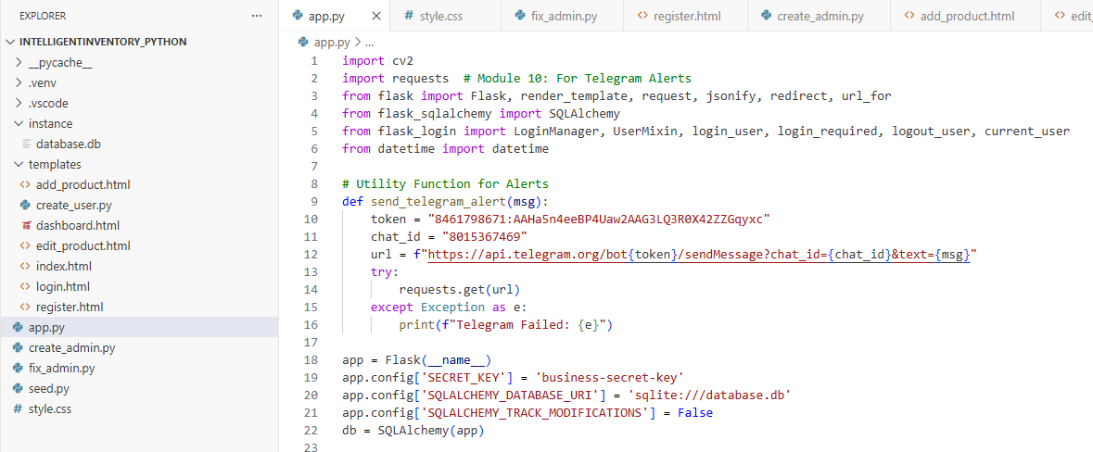
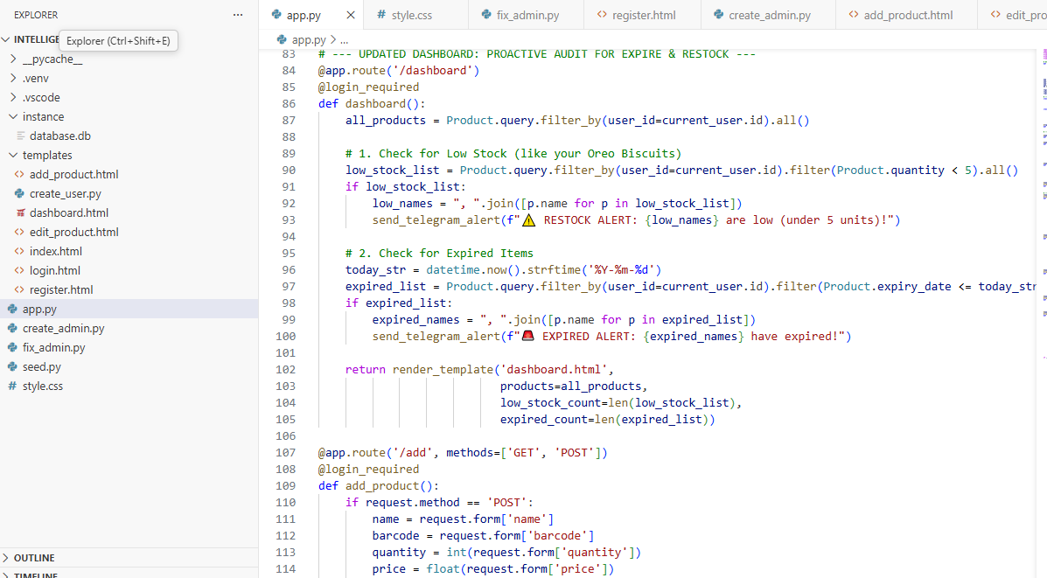
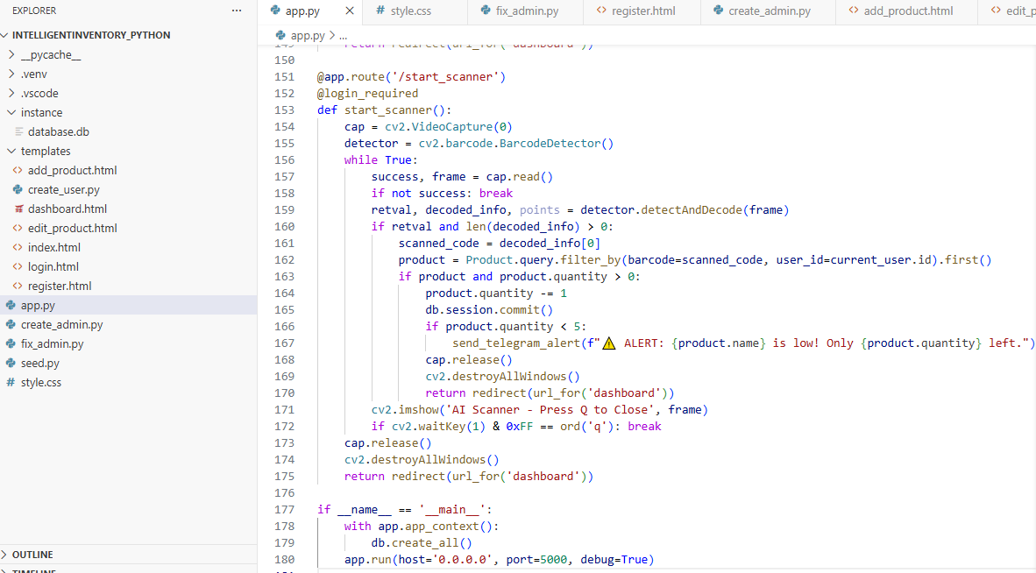
4.1.2. Frontend UI & AI Interactivity (dashboard.html)
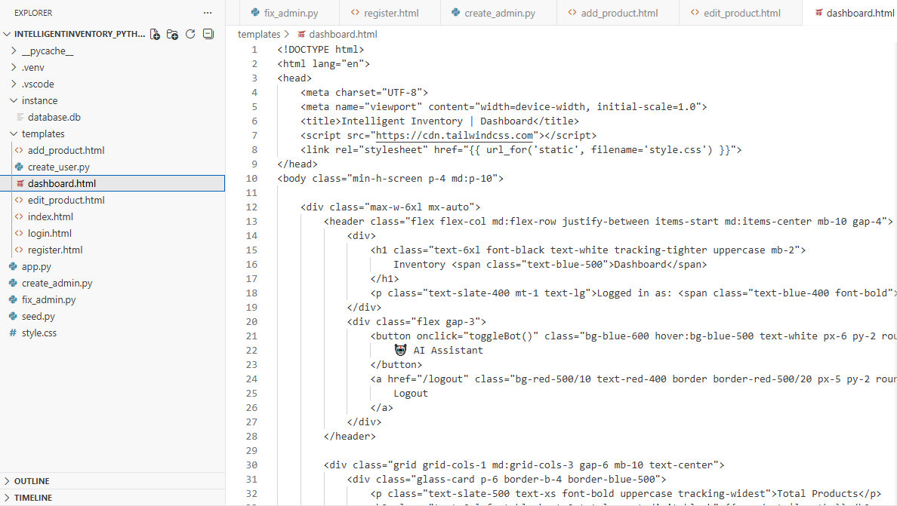
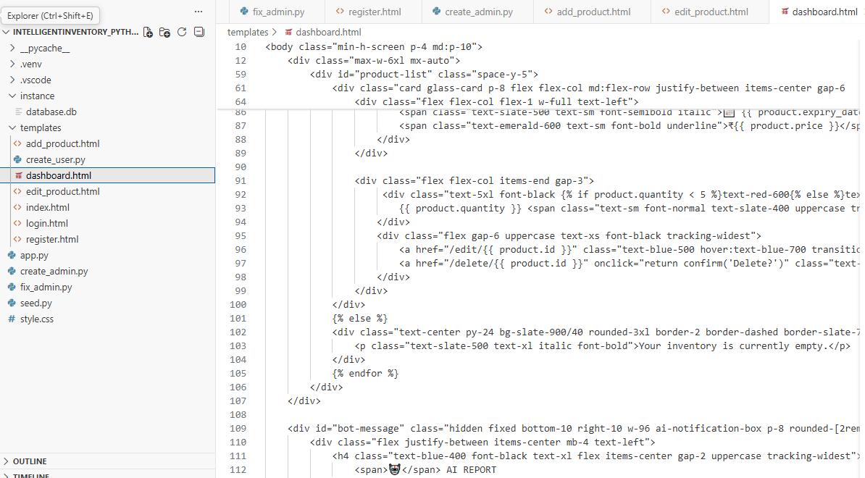
4.1.3 Database Configuration
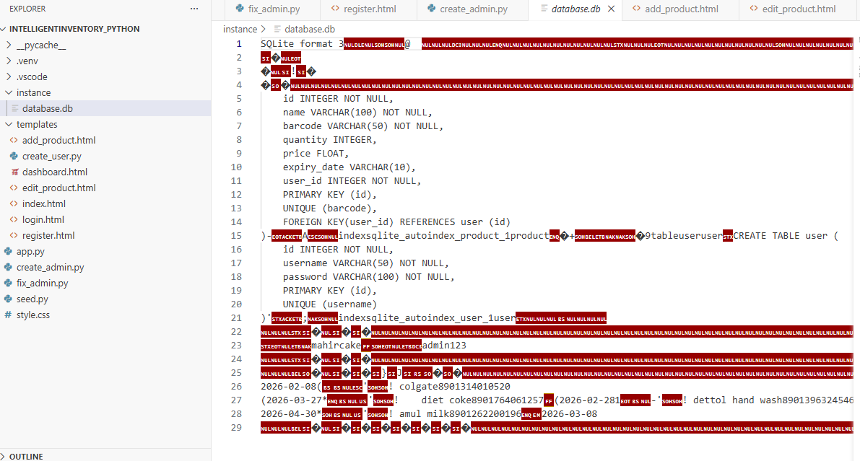4.1.4 User Authentication
Index.html
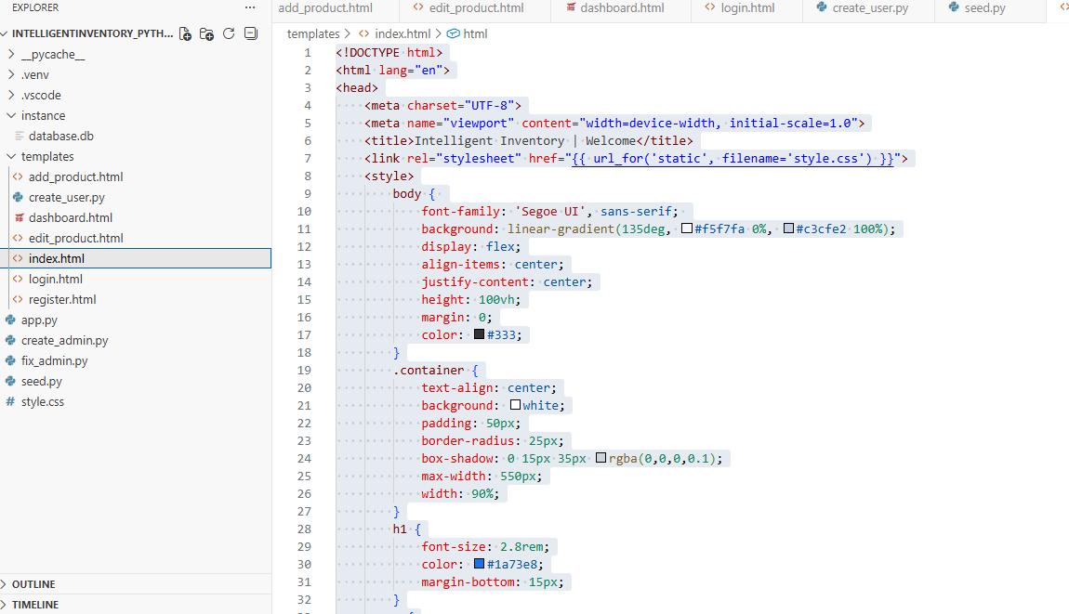
Login.html
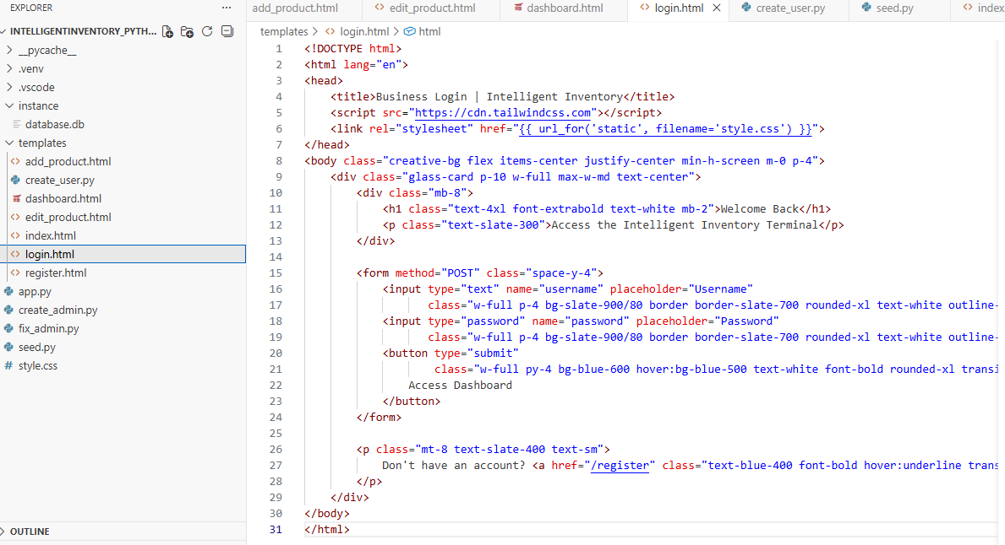
Register.html
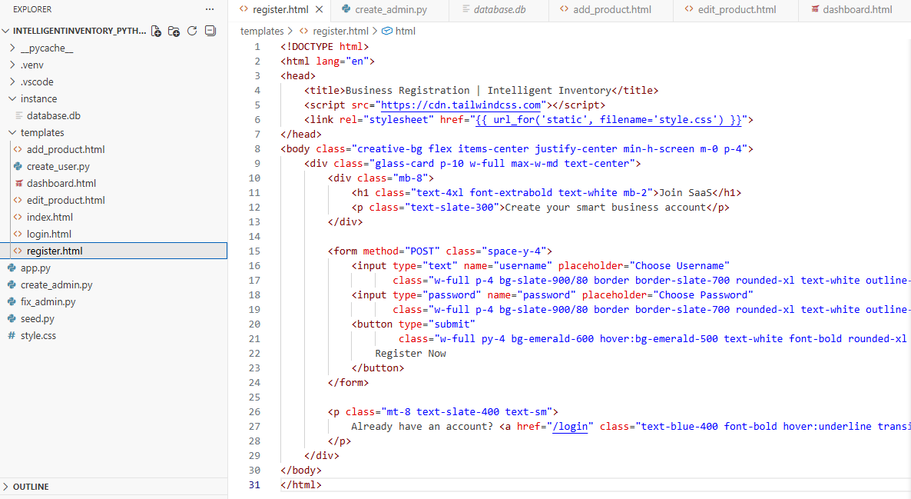

4.1.5 Inventory Operations (Add & Edit)

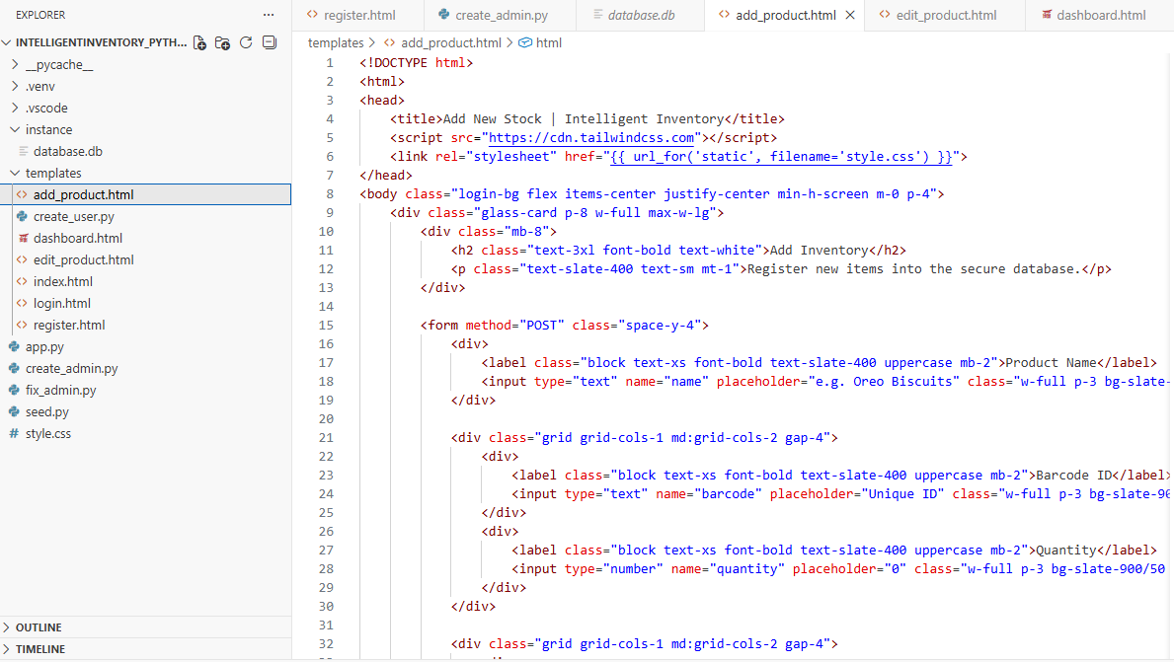
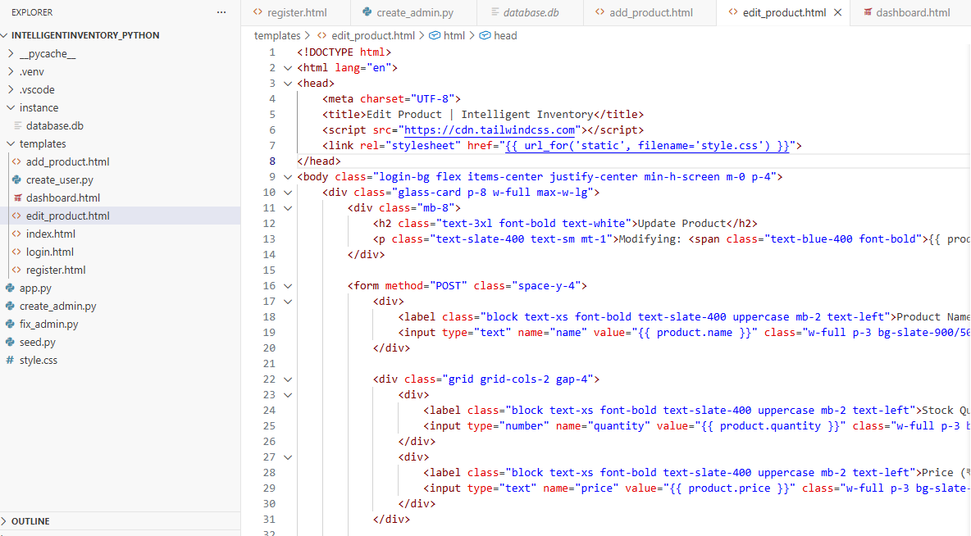

4.1.6 Global Styling (style.css)
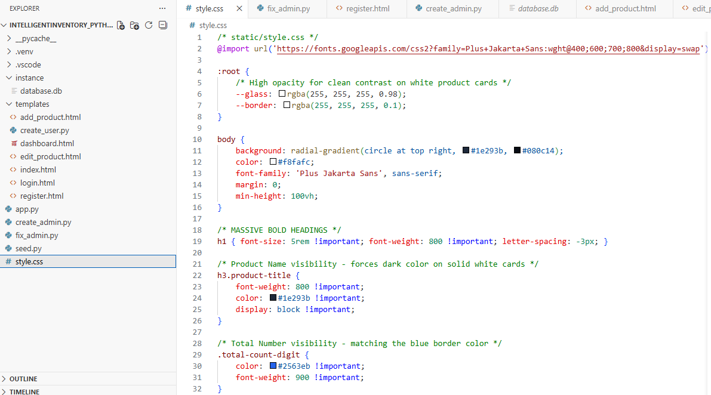
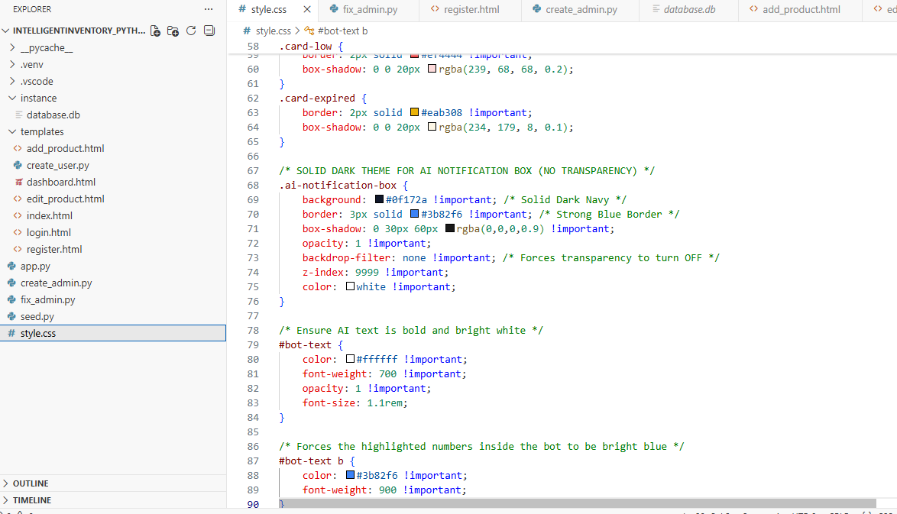
4.1.7 Command to run the code
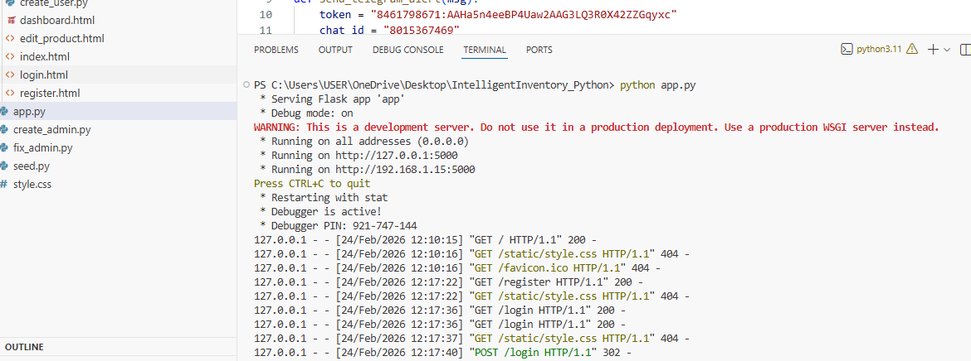

4.2 Testing Approach
Testing plays a crucial role in validating the reliability, accuracy, and robustness of the Intelligent Inventory Bot. Since the system integrates multiple technologies—Flask for backend logic, OpenCV for barcode detection, SQLAlchemy for database management, and the Telegram Bot API for IoT notifications—a layered testing strategy was adopted. This strategy progresses from testing individual modules to evaluating the complete system in a real-world environment.
The testing methodology follows a bottom-up approach, ensuring that foundational components are stable before validating inter-module interactions and full system behavior.

4.2.1 Unit Testing
Unit testing focuses on verifying the correctness of individual components in isolation. Each function or module was tested independently to ensure predictable behavior under controlled conditions.
- Database Models:
SQLAlchemy models were tested to confirm successful table creation, enforcement of primary and foreign key constraints, and prevention of duplicate barcode entries through unique constraints.
- Utility and Helper Functions:
The send_telegram_alert function was tested separately to validate proper JSON payload construction, correct API endpoint usage, and successful handling of HTTP responses.
- Authentication and Security Modules:
Password hashing and verification mechanisms were tested to ensure that plaintext passwords are never stored and that login authentication functions correctly under valid and invalid credentials.
- Computer Vision Module:
The OpenCV-based scanning logic was tested using sample barcode images to verify accurate decoding, correct string extraction, and graceful handling of unreadable or invalid barcodes.

4.2.2 Integration Testing
Integration testing validates communication and data flow between interconnected modules. This phase ensures that individually working components function correctly when combined.
- Scanner-to-Database Integration:
Verified that barcode data decoded by OpenCV is successfully transmitted to the Flask backend, triggering product lookup and quantity updates in the database.
- Inventory Logic to IoT Notification Engine:
Confirmed that inventory threshold conditions correctly invoke the Telegram Bot API only when stock levels fall below the predefined limit, preventing false alerts.
- Frontend-to-Backend Communication:
Tested the interaction between the HTML/Bootstrap-based dashboard and Flask routes using AJAX calls to ensure real-time updates without page reloads.

4.2.3 Beta Testing
Beta testing represents the final validation phase, where the system is deployed in a controlled real-world environment and tested by actual end-users.
- Real-World Usage Conditions:
The system was tested in a live retail setup to observe scanner performance under varying lighting conditions, barcode orientations, and camera distances.
- User Experience Evaluation:
Feedback was collected from shopkeepers regarding dashboard usability, readability of stock information, and the usefulness of Telegram notifications in daily operations.
- Issue Identification and Documentation:
Minor issues such as camera initialization delay and occasional network latency in alert delivery were identified. These were documented and later addressed or listed as system limitations.

4.3 Test Case Design
Test cases are defined to verify whether the system meets its functional and non-functional requirements. For the Intelligent Inventory Bot, test cases were designed to validate authentication, inventory automation, security controls, and intelligent alert mechanisms.

Test Case ID | Feature | Input/Action | Expected Result | Status
TC_01 | Login | Correct username & password. | Access granted to dashboard. | Pass
TC_02 | Scanning | Present 1D Barcode to Webcam. | Quantity decrements in DB. | Pass
TC_03 | IoT Alert | Decrease stock count below 5. | Telegram notification received. | Pass
TC_04 | Security | Access dashboard without login. | Redirected to login page. | Pass

CHAPTER 5: CONCLUSION

5.1 Conclusion
The Intelligent Inventory Bot successfully addresses key operational challenges faced by small-scale retailers by integrating Computer Vision and IoT technologies into a unified SaaS-based platform. Throughout the project lifecycle, all major objectives were effectively achieved.
Automation of Stock Management:
By leveraging OpenCV-based image processing, the system eliminates the need for manual stock entry, significantly reducing human error and improving inventory accuracy.
Proactive Monitoring:
The integration of the Telegram Bot API converts a traditionally passive inventory system into an active assistant, delivering real-time alerts for low stock levels and product expiry, thereby enabling timely decision-making.
User-Centric and Secure Design:
The application ensures a secure, multi-user environment through Flask-Login and SQLAlchemy, maintaining data isolation and protecting sensitive business information for each retailer.
Scalability and Maintainability:
The modular system architecture, as illustrated in the Component and Deployment diagrams, allows seamless feature expansion and system upgrades without affecting existing functionalities.
In conclusion, this project demonstrates how cost-effective AI and IoT solutions can be practically applied to modernize traditional retail operations, improving efficiency, accuracy, and responsiveness while remaining accessible to small-scale businesses.

5.2 Limitations of the System
While the Intelligent Inventory Bot offers a reliable and automated solution for retail inventory management, certain technical and operational limitations were observed during development and testing. Identifying these constraints helps define the scope and boundaries of the current implementation.
- Dependency on Lighting Conditions:
The accuracy of OpenCV-based barcode detection is highly dependent on ambient lighting conditions. Poor or uneven lighting can result in delayed scanning or failure to decode barcodes correctly.
- Hardware Constraints:
The system currently operates using a fixed laptop webcam, which restricts portability and flexibility when compared to dedicated handheld barcode scanners or mobile-based scanning solutions.
- Limited Barcode Support:
The present implementation is optimized for standard 1D barcodes such as UPC and EAN. Advanced formats like QR codes, Data Matrix codes, and RFID tags are not supported.
- Internet Dependency for IoT Notifications:
The Telegram-based notification system requires a stable internet connection. Network interruptions can prevent the timely delivery of low-stock or product-expiry alerts.
- Manual Product Registration:
Although stock updates are automated through barcode scanning, the initial entry of new product details (such as name and price) must be manually added to the database.
- Local Hosting Restrictions:
Since the application is hosted on localhost (127.0.0.1), remote access to the dashboard and scanner is not possible outside the local network environment.

5.3 Future Scope
The Intelligent Inventory Bot can be further enhanced to improve accessibility, intelligence, and real-world usability. Several potential extensions are identified below:
Cloud Deployment and Remote Access:
In future versions, the system can be deployed on cloud platforms such as AWS or Heroku. Cloud hosting would allow shopkeepers to access the inventory dashboard from any location using a web browser, enable automatic backups, and support multiple stores under a single account. It would also improve system scalability as the number of users grows.
Mobile Application Integration:
A dedicated mobile application developed using Flutter can be integrated with the system. This would allow users to scan products using smartphone cameras, eliminating the need for a fixed webcam setup. Mobile support would increase portability and make the system more practical for small and medium-sized retailers.
Support for Multiple Barcode Formats:
The computer vision module can be upgraded to detect and decode QR codes and Data Matrix barcodes in addition to traditional 1D barcodes. This enhancement would improve compatibility with modern packaging standards and enable the storage of richer product information.
Predictive Inventory Management:
Machine Learning algorithms can be introduced to analyze historical sales data and seasonal demand patterns. Based on this analysis, the system can provide intelligent reorder suggestions, stock forecasting, and alerts to prevent overstocking or stock shortages.
Supplier and Billing Integration:
Future enhancements may include supplier management and automated invoice generation. This would allow retailers to directly place orders with suppliers and generate digital bills, creating a more complete retail management solution.

REFERENCES
The development of the Intelligent Inventory Bot was supported by various academic resources, technical documentation, and software repositories. Below is a list of the primary references used for the research, design, and implementation phases of the project.

A. Books and Academic References
- Pressman, R. S., "Software Engineering: A Practitioner's Approach," McGraw-Hill Education. (Used for Agile methodology and UML standards).
- Elmasri, R., & Navathe, S. B., "Fundamentals of Database Systems," Pearson Education. (Referenced for Schema Design and Entity-Relationship modeling).
- Grinberg, M., "Flask Web Development: Developing Web Applications with Python," O'Reilly Media. (Guidance for Flask-Login and SQLAlchemy integration).

B. Technical Documentation and APIs
- Flask Documentation (2.x): Official guide for routing, session management, and template rendering.
- OpenCV-Python Tutorials: Documentation for the VideoCapture and BarcodeDetector classes used in the AI Vision module.
- SQLAlchemy ORM Documentation: Reference for mapping Python classes to SQLite database tables.
- Telegram Bot API: Technical specifications for dispatching automated IoT messages and HTTP POST requests.

C. Online Resources and Research Papers
- IEEE Xplore / ResearchGate: Consulted for papers regarding "IoT-based Inventory Systems" and "Real-time Barcode Recognition using OpenCV".
- W3Schools & Stack Overflow: Utilized for front-end styling with Bootstrap and debugging Python-Flask integration issues.
- Diagrams.net (draw.io): Used for the creation of all UML diagrams including Activity, Sequence, and Deployment charts.

GLOSSARY
The following glossary provides definitions for the technical terms and acronyms used throughout the Intelligent Inventory Bot project report. These terms are essential for understanding the underlying technologies of SaaS, AI, and IoT.

Term | Definition
AI (Artificial Intelligence) | The simulation of human intelligence in machines that are programmed to think and learn.
API (Application Programming Interface) | A set of rules that allows different software entities to communicate with each other (e.g., Flask communicating with Telegram).
Barcode | A machine-readable representation of data in a visual format on a surface; 1D barcodes are used in this project.
CRUD | An acronym for Create, Read, Update, and Delete—the four basic functions of persistent storage.
Flask | A lightweight WSGI web application framework in Python used to build the system backend.
IoT (Internet of Things) | A network of physical objects embedded with sensors and software for the purpose of connecting and exchanging data.
OpenCV | An open-source computer vision and machine learning software library used here for real-time image processing.
ORM (Object-Relational Mapping) | A technique that lets you query and manipulate data from a database using an object-oriented paradigm (e.g., SQLAlchemy).
SaaS (Software as a Service) | A software licensing and delivery model in which software is licensed on a subscription basis and is centrally hosted.
SQLAlchemy | The Python SQL toolkit and Object Relational Mapper that gives application developers the full power and flexibility of SQL.
SQLite | A C-language library that implements a small, fast, self-contained, high-reliability, full-featured, SQL database engine.
UML (Unified Modeling Language) | A general-purpose, developmental, modeling language in the field of software engineering that is intended to provide a standard way to visualize the design of a system.

